**Matplotlib anatomy:**

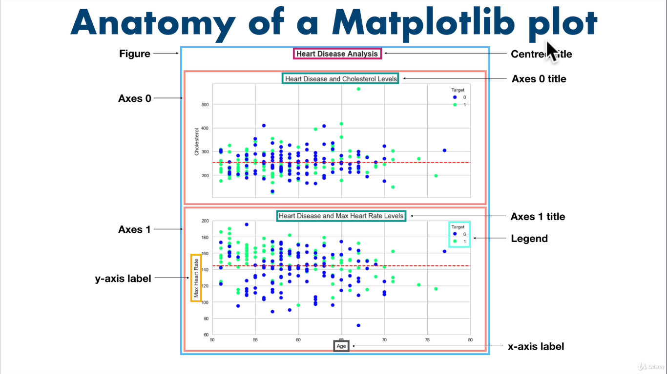

**Object oriented API:**

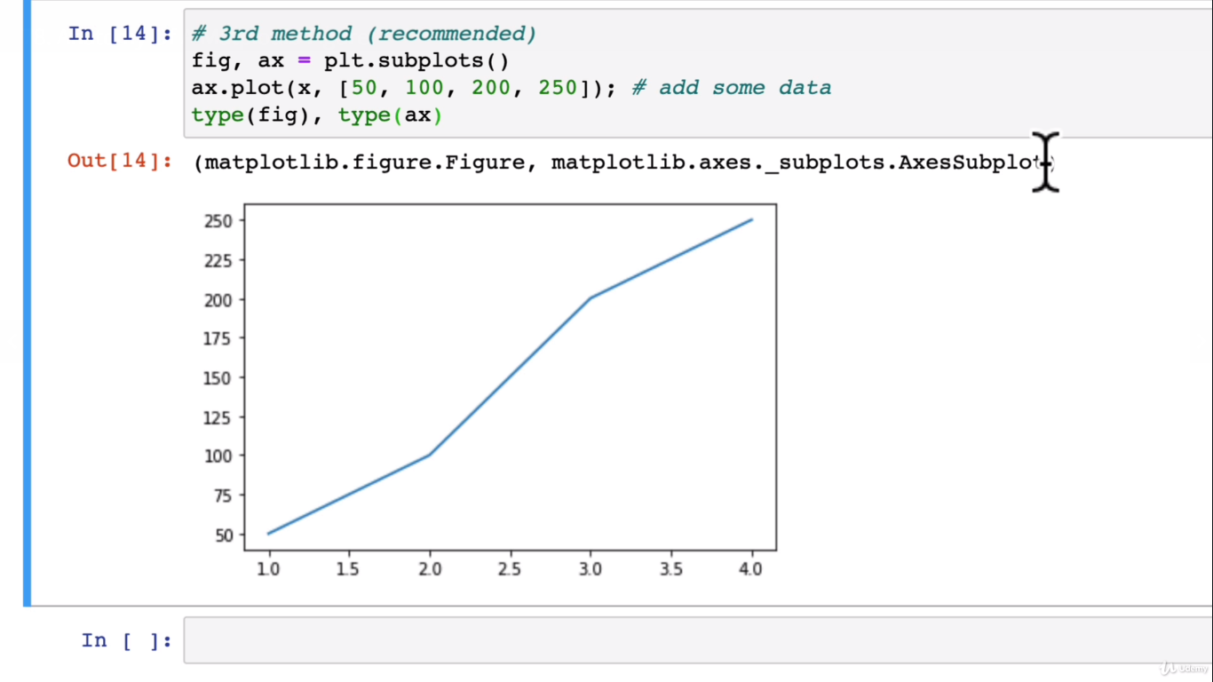

**Creating a plot:**

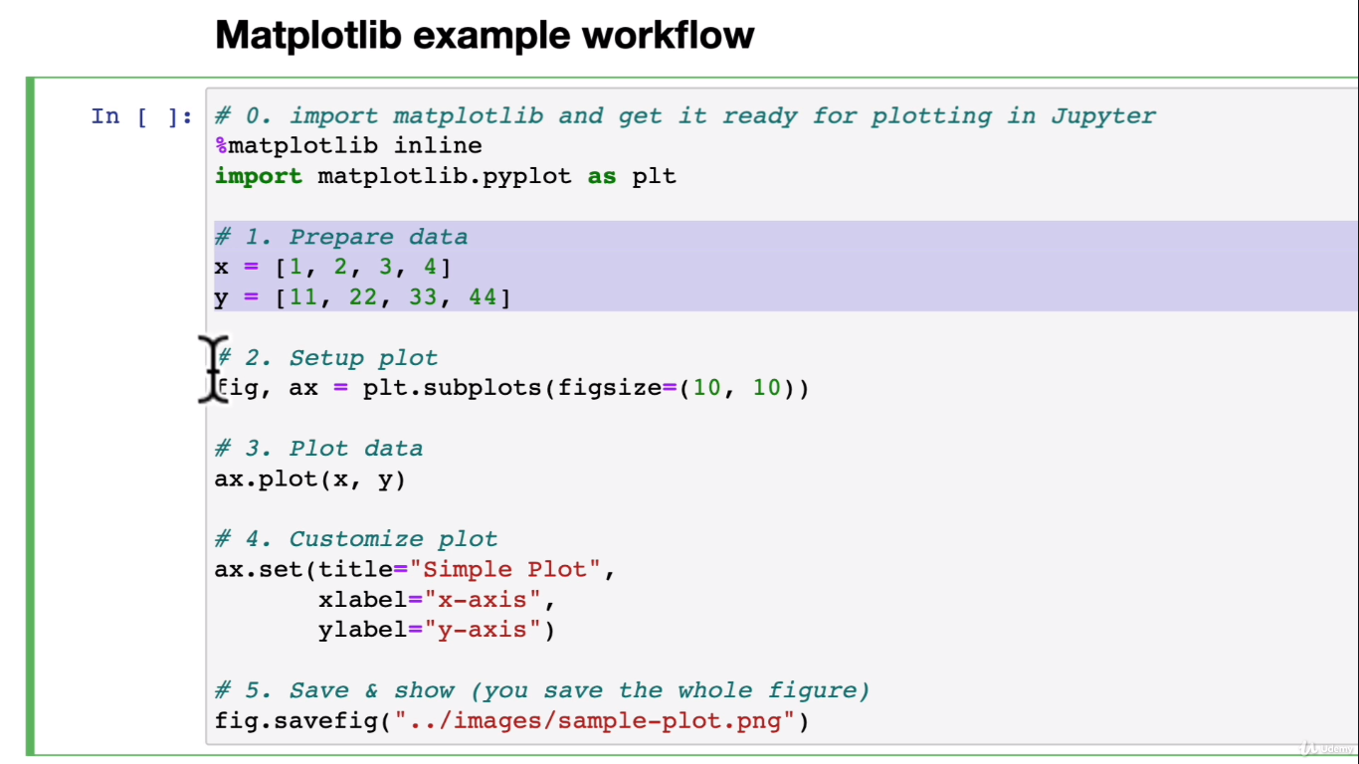

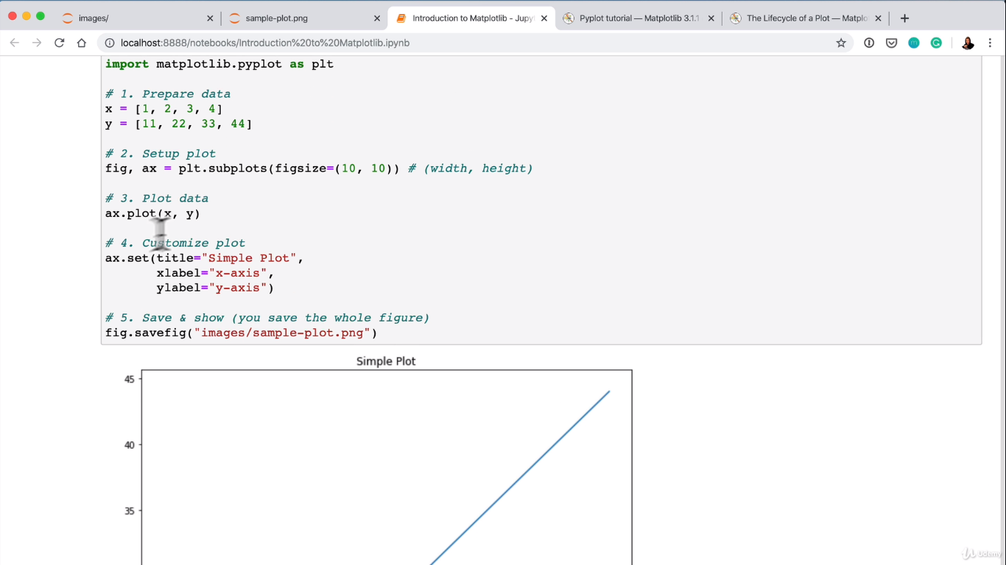

**Scatter plot and bar plot:**

**Making figures with numpy arrays:**

Import numpy as np

X = np.linspace(0,10,100)

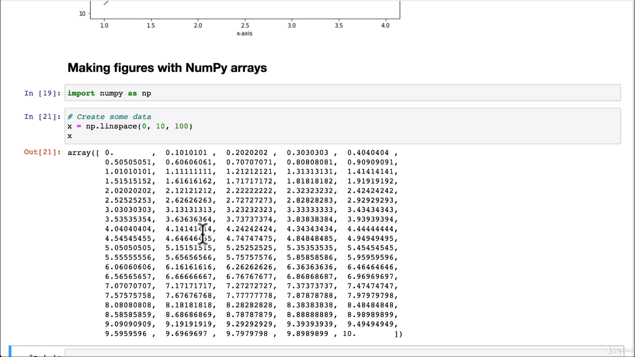

**#plot the data**

Fig, ax = plt.subplots()

Ax.plot(x,x**2);

**Scatter plots:**

Fig, ax = plt.subplots()

Ax.scatter(x,np.exp(x));

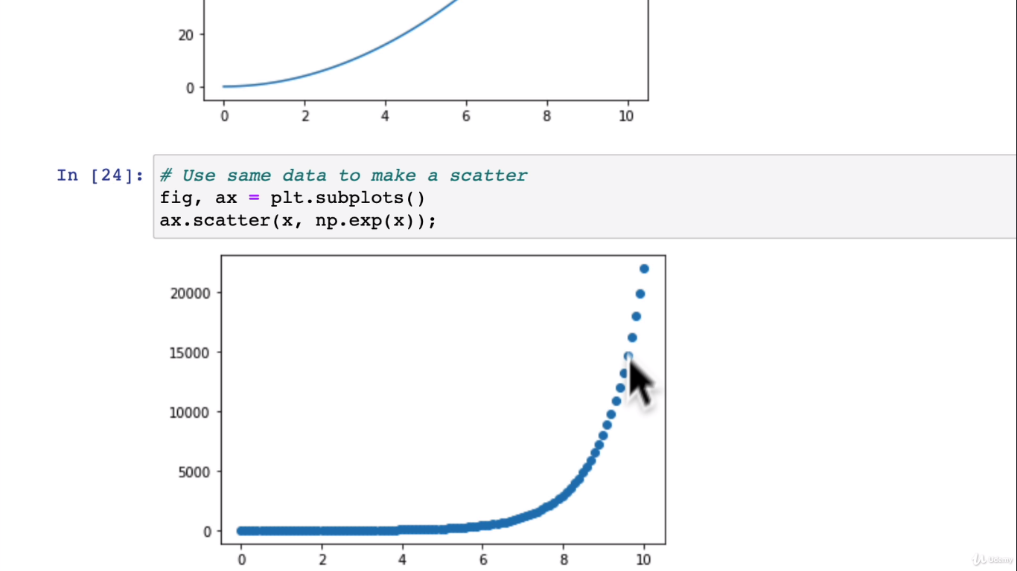

#Another scatter plot:

Fig, ax = plt.subplots()

Ax.scatter(x,np.sin(x)); ( Like SineTheta in trigonometry)

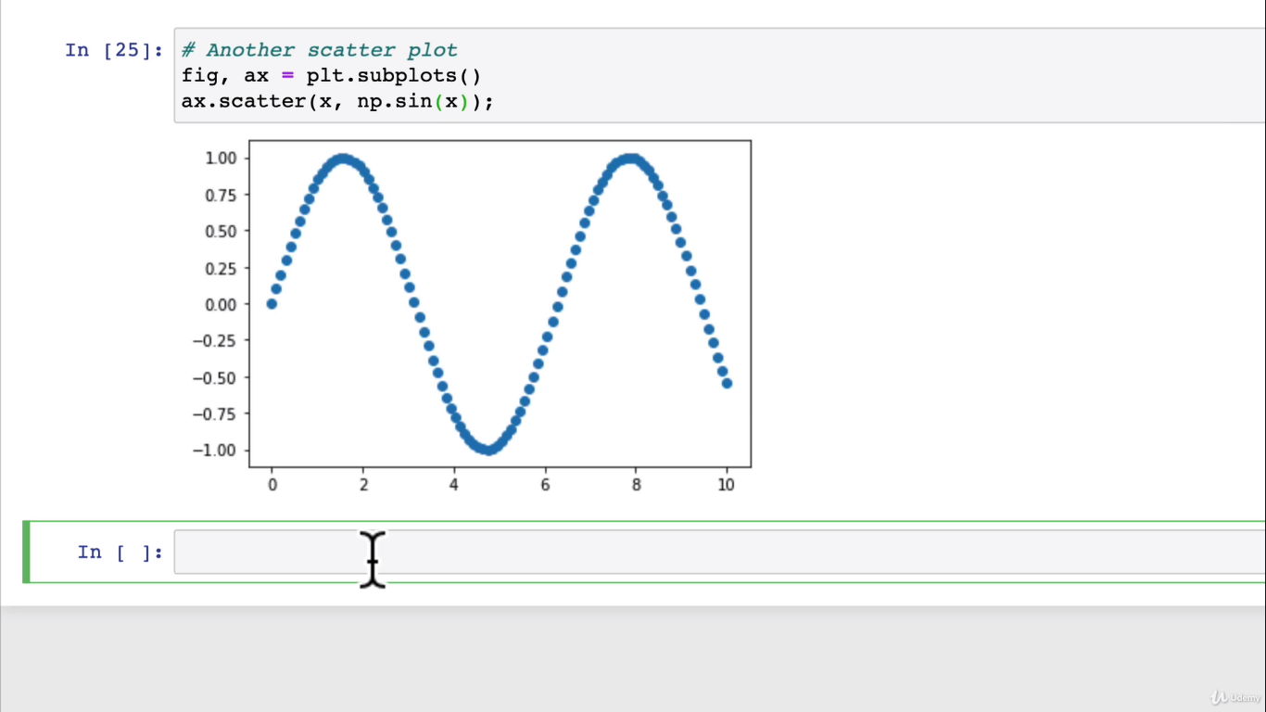

**#Make a plot from Dictionary:**

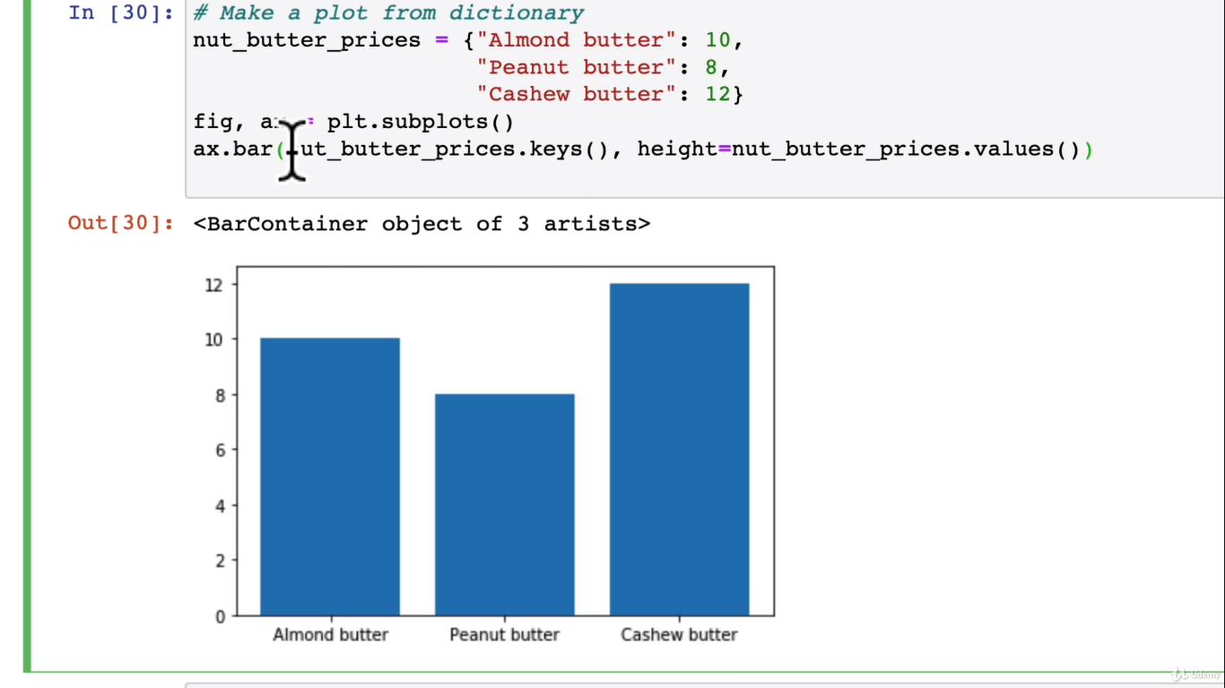

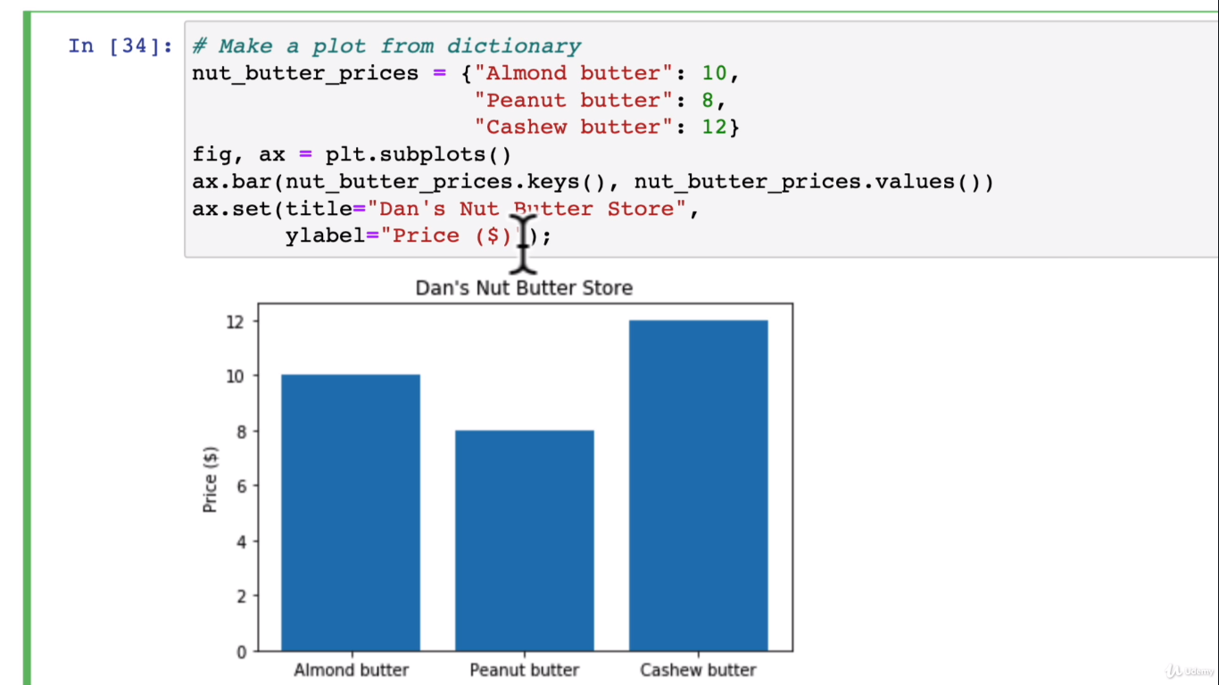

**Horizontal bar:**

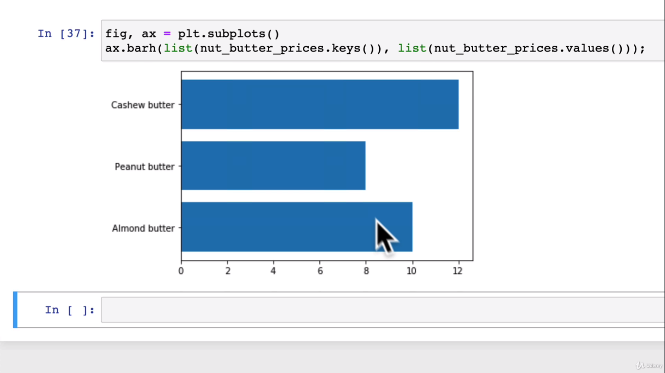

**Histograms:**

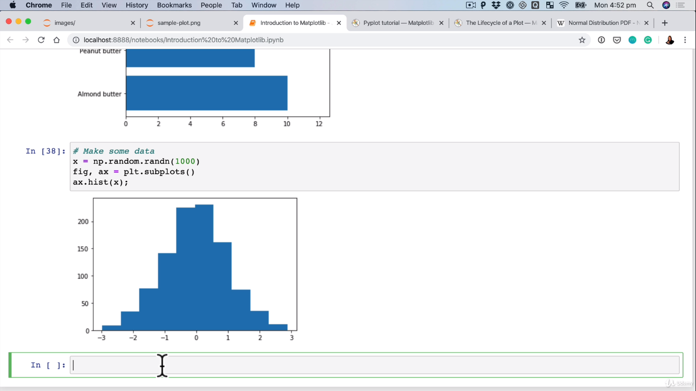

**Two options for subplots:**

**#option1**

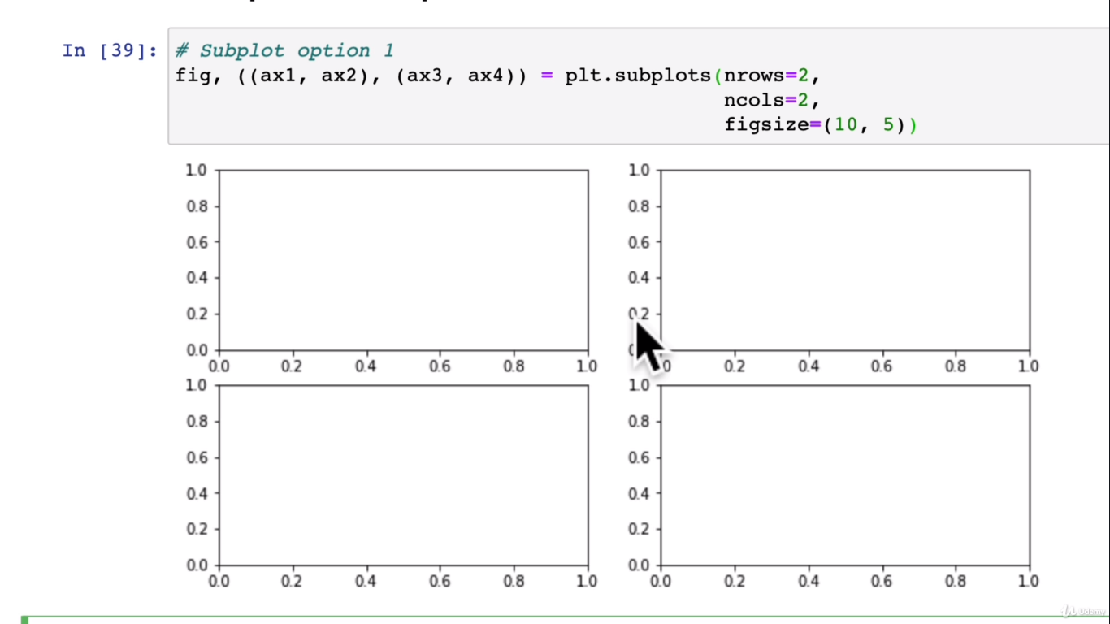

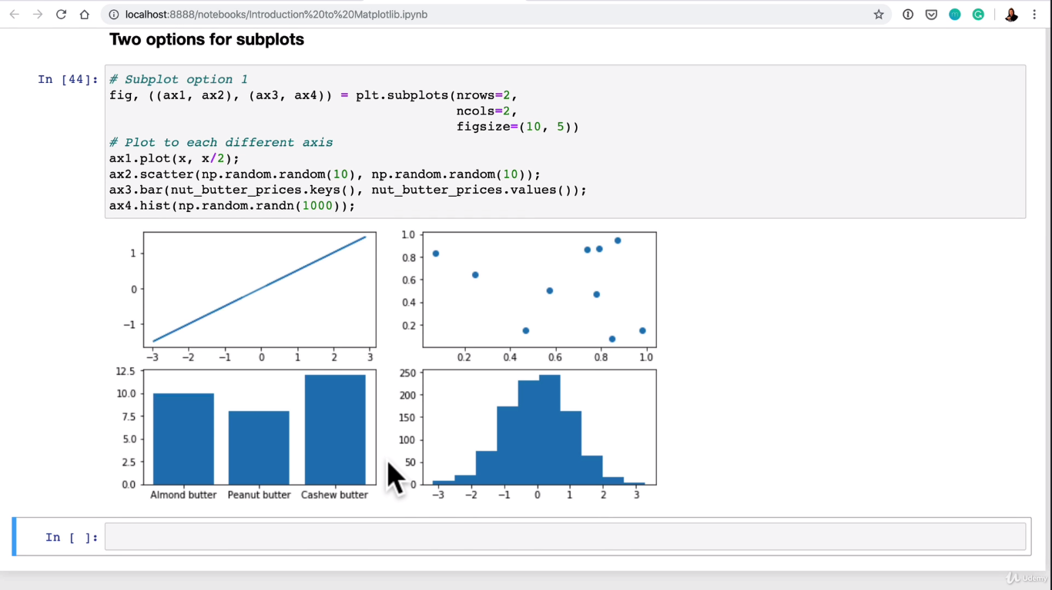

**Subplots option2:**

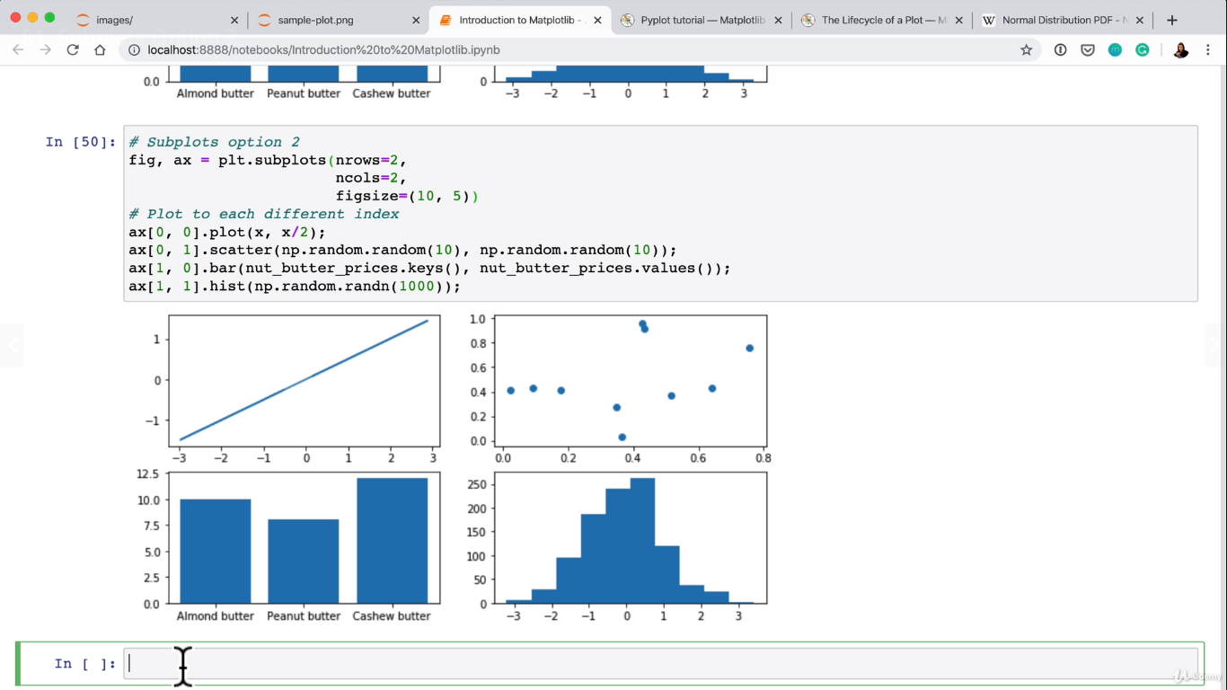

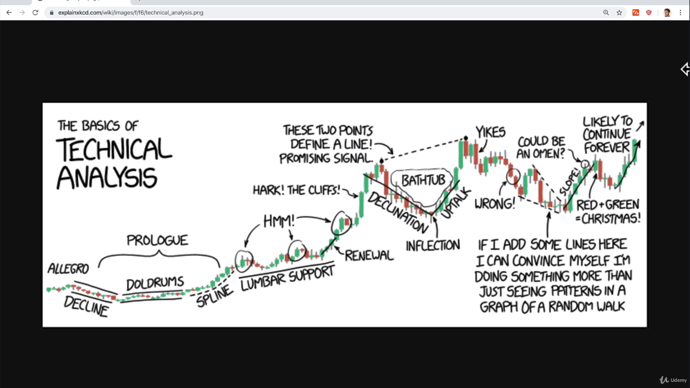

**Plotting from pandas dataframes:**

**Plotting from series:**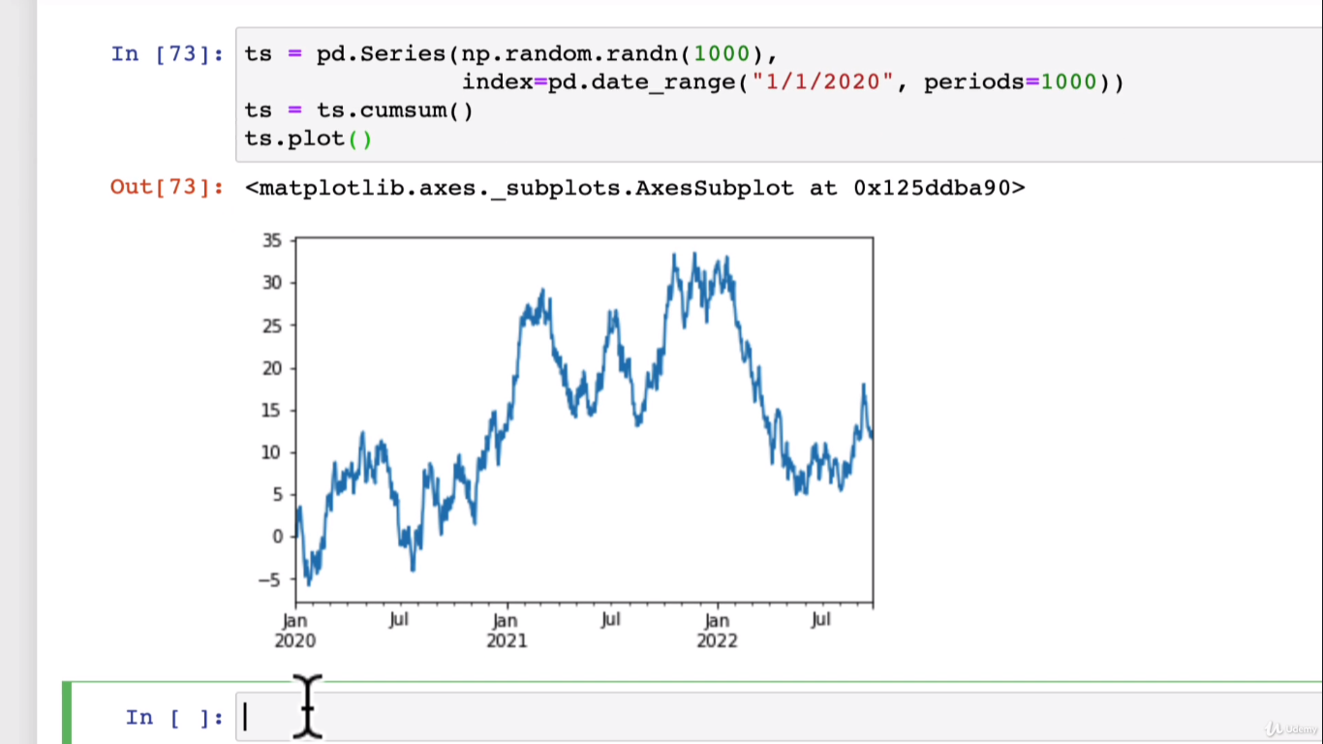

**Plotting from pandas dataframe:**

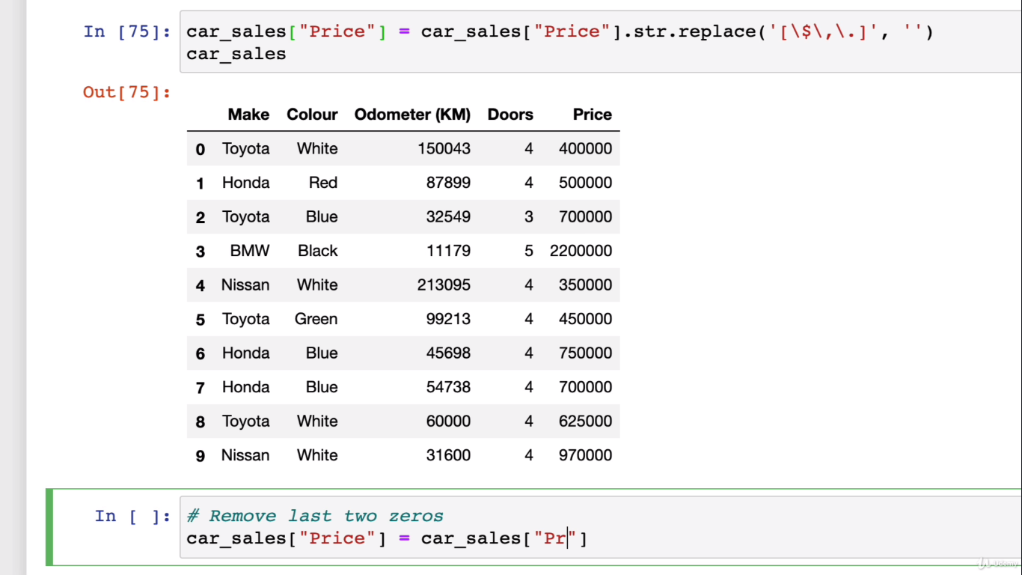

Add regex and change dollar to string

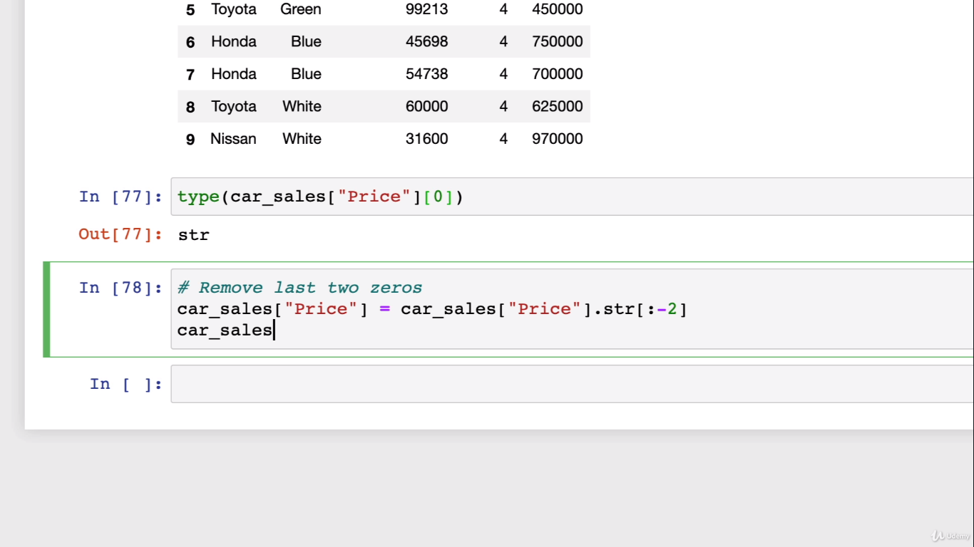

**Add a column:**

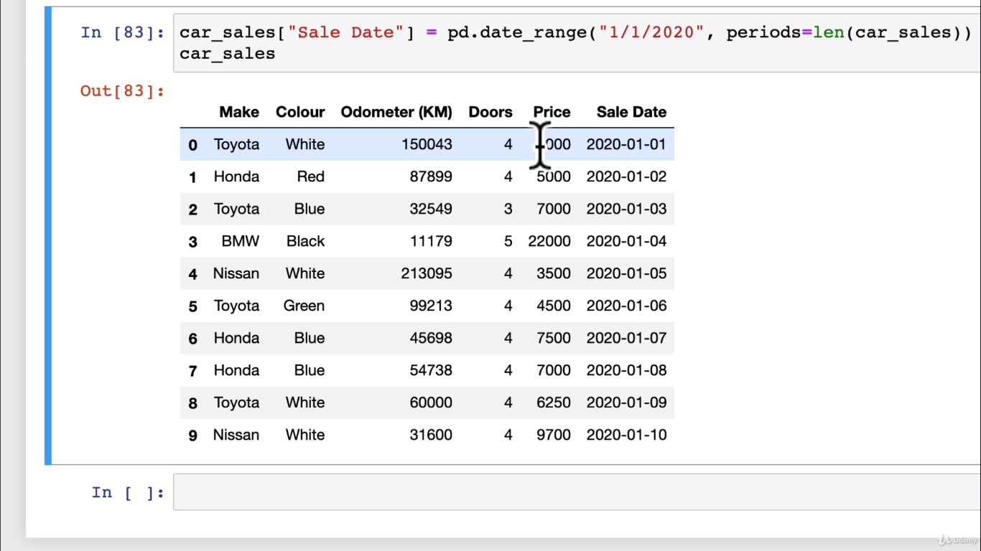

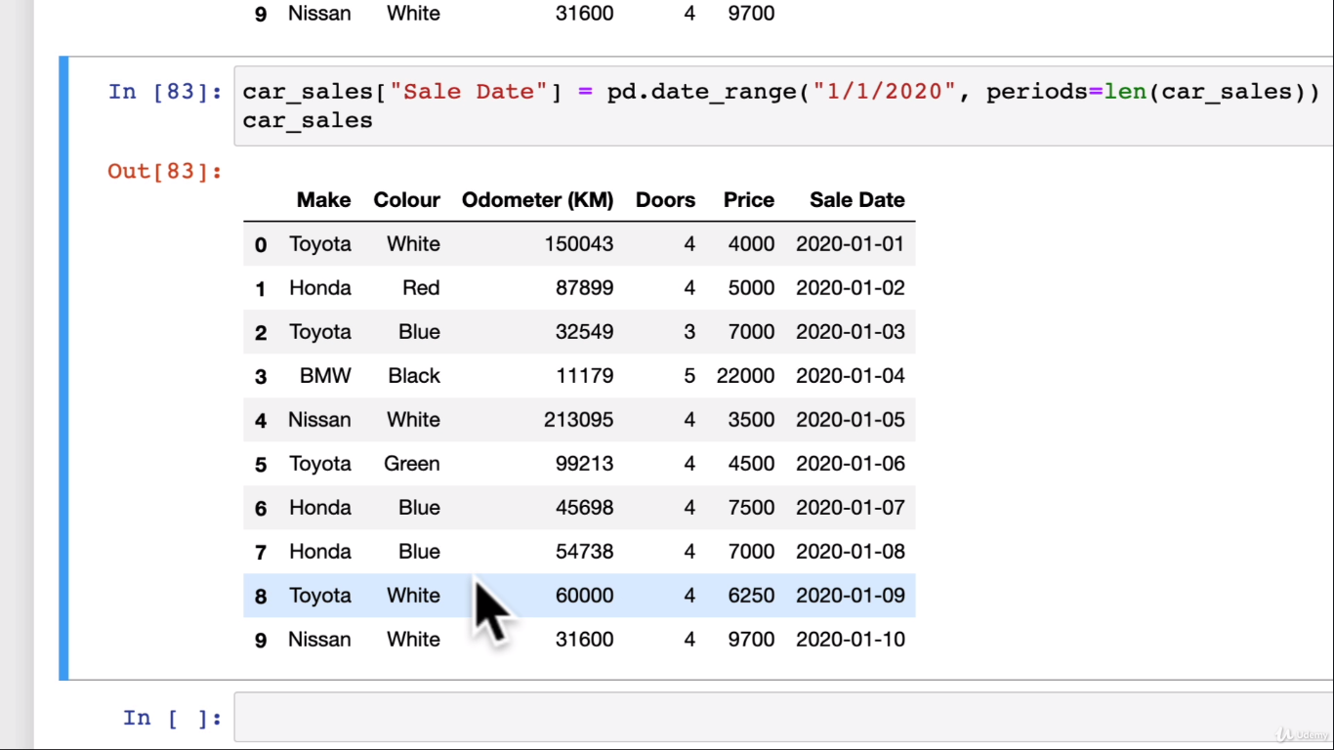

**Cumsum() : To have car sales total sales:**

**Since it is still string it did not work properly so we need to change it to integer and then do the cumsum**

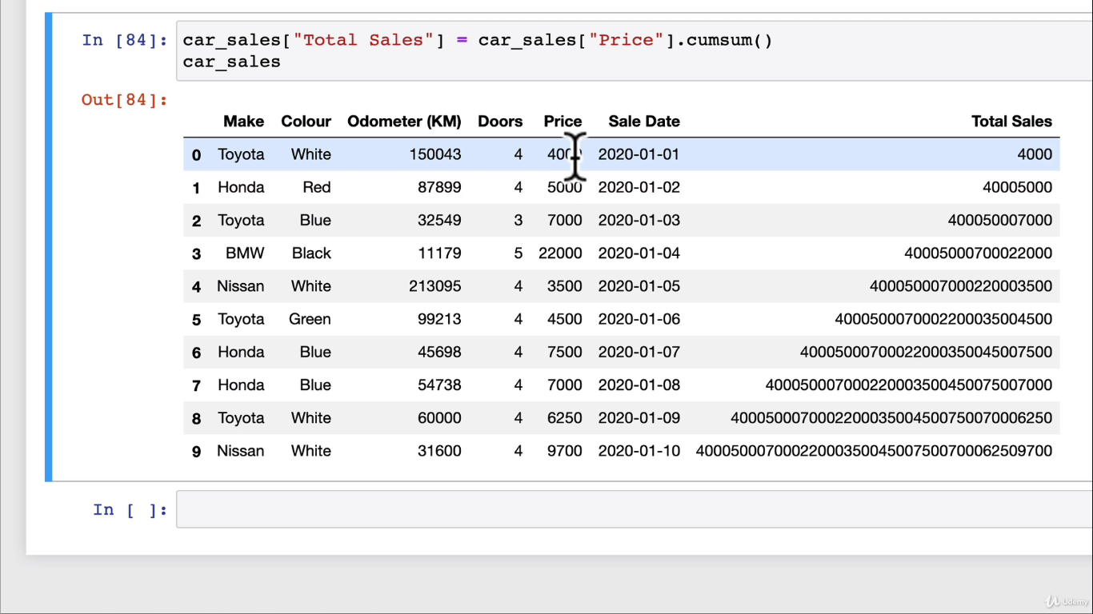

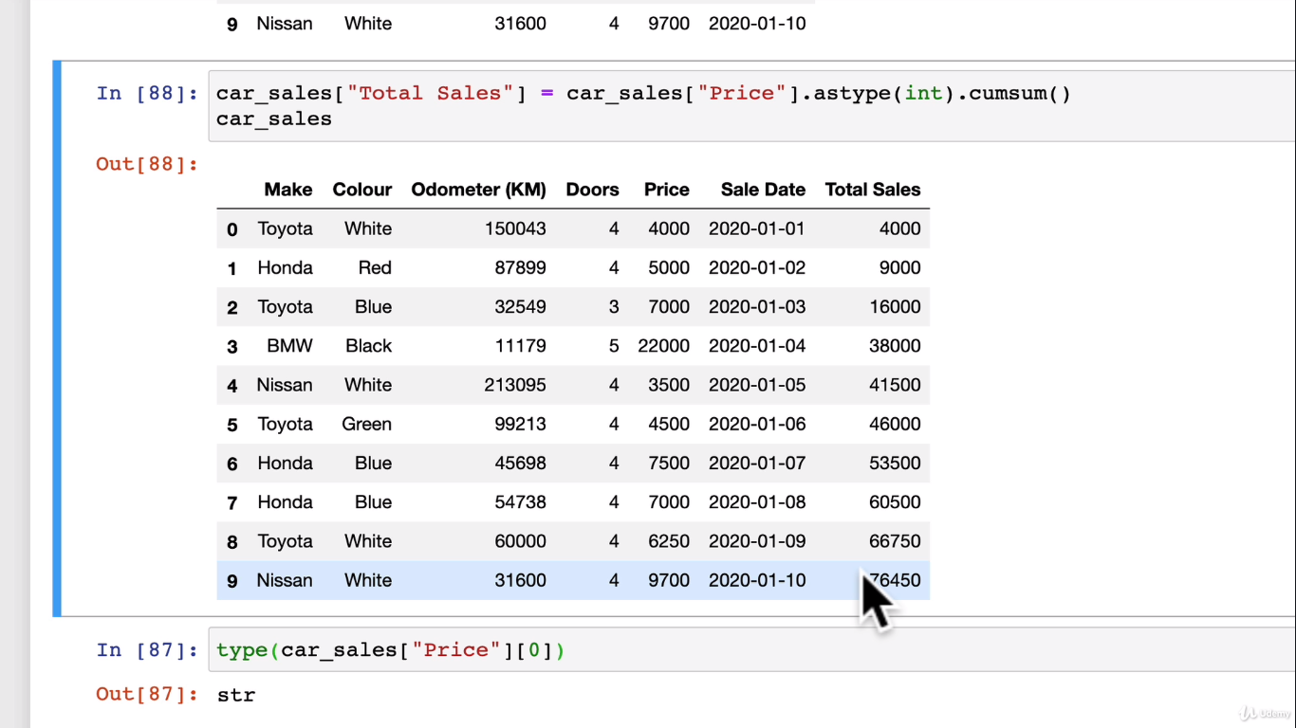

**Let’s plot the total_sales:**

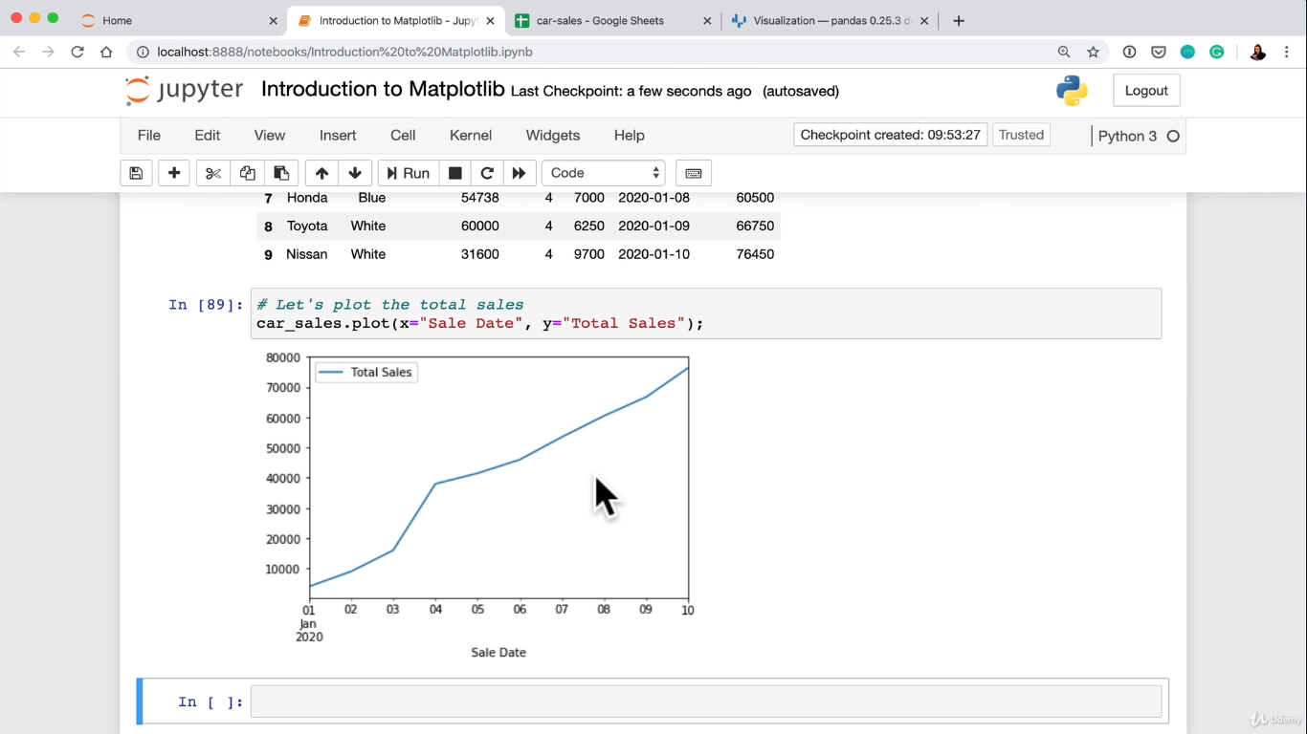

**Scatter plot:**

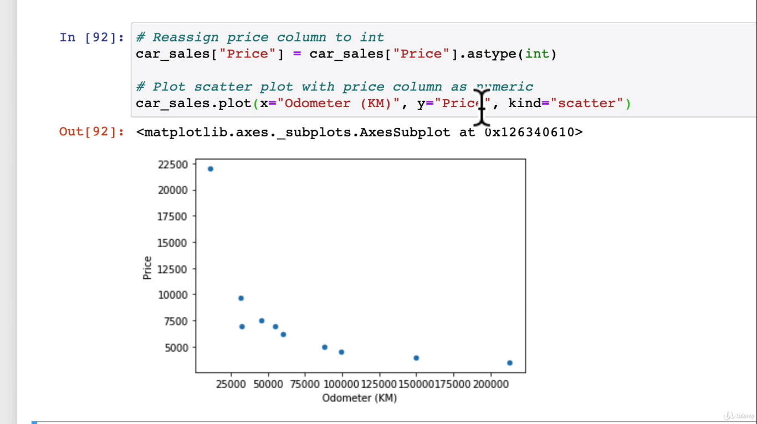

**Bar Graph using pandas datafrme:**

**One more method is**

**Df.plot(kind=”bar”);**

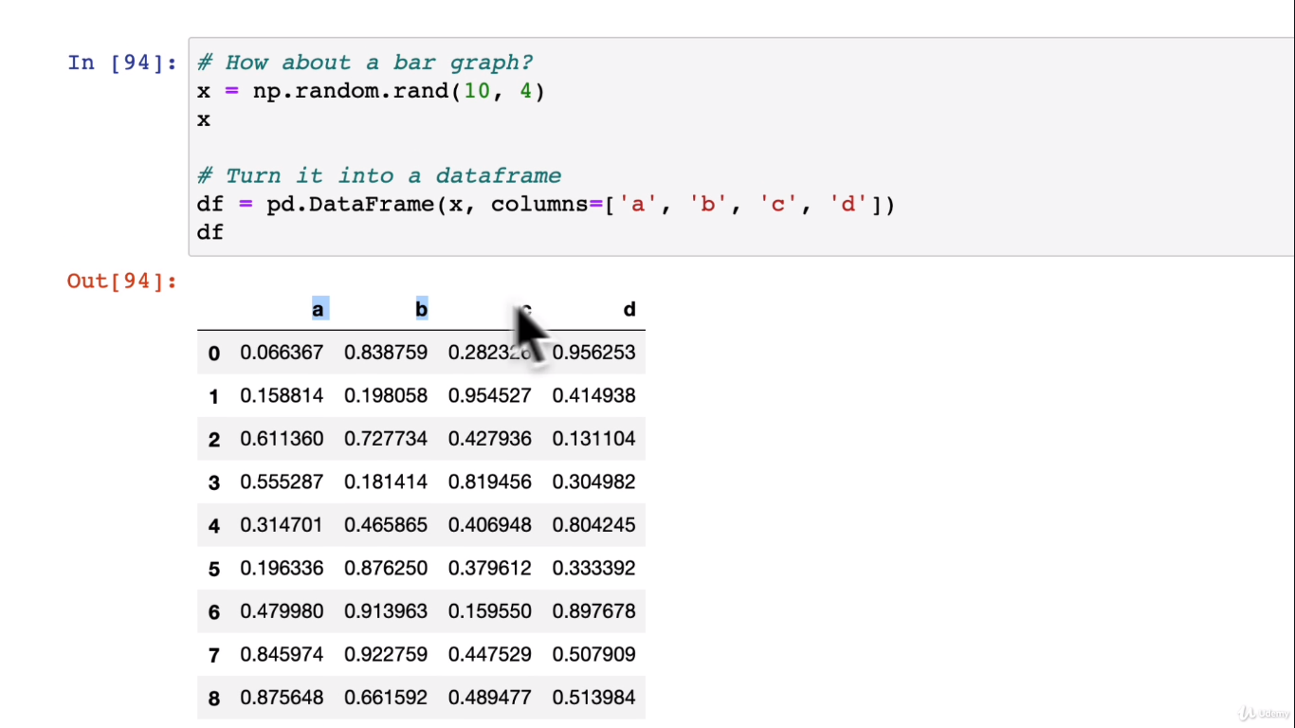

**Bar chart for a particular columns:**

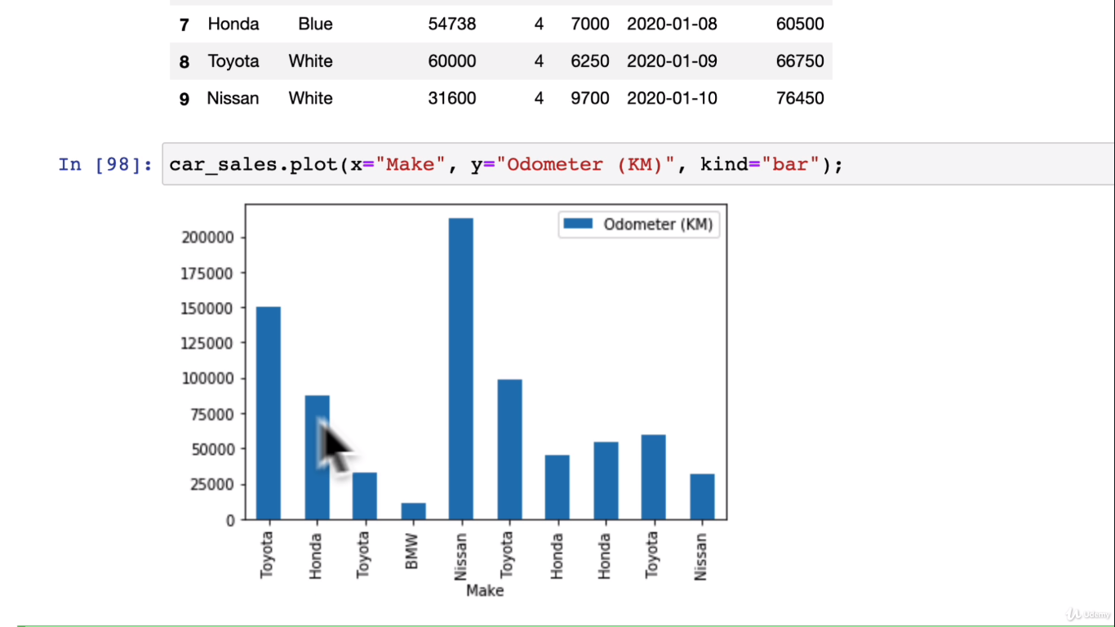

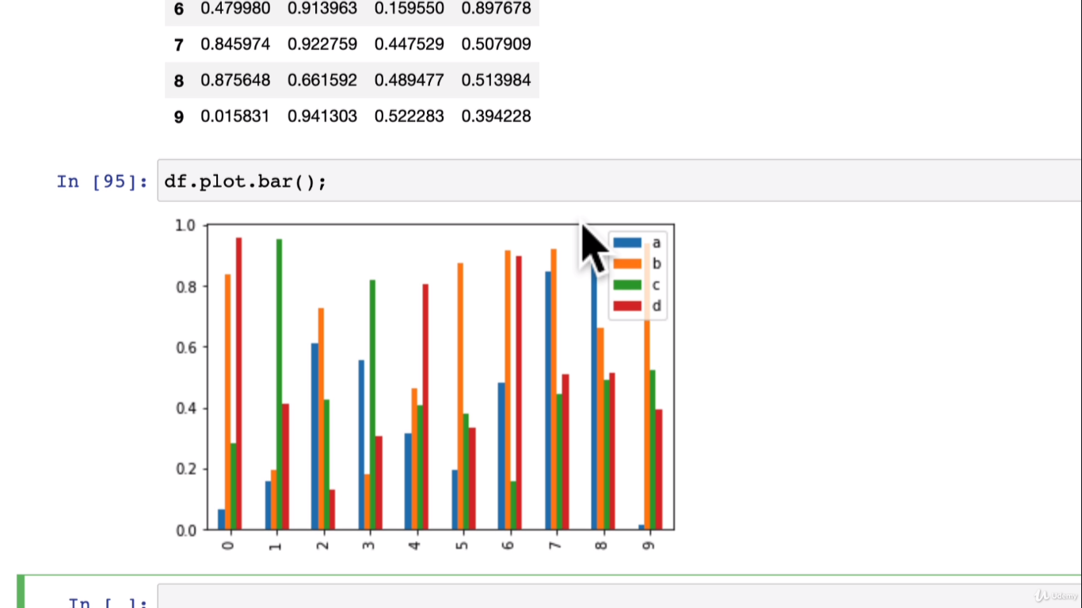

**Histograms are great for dpread of data visualization:**

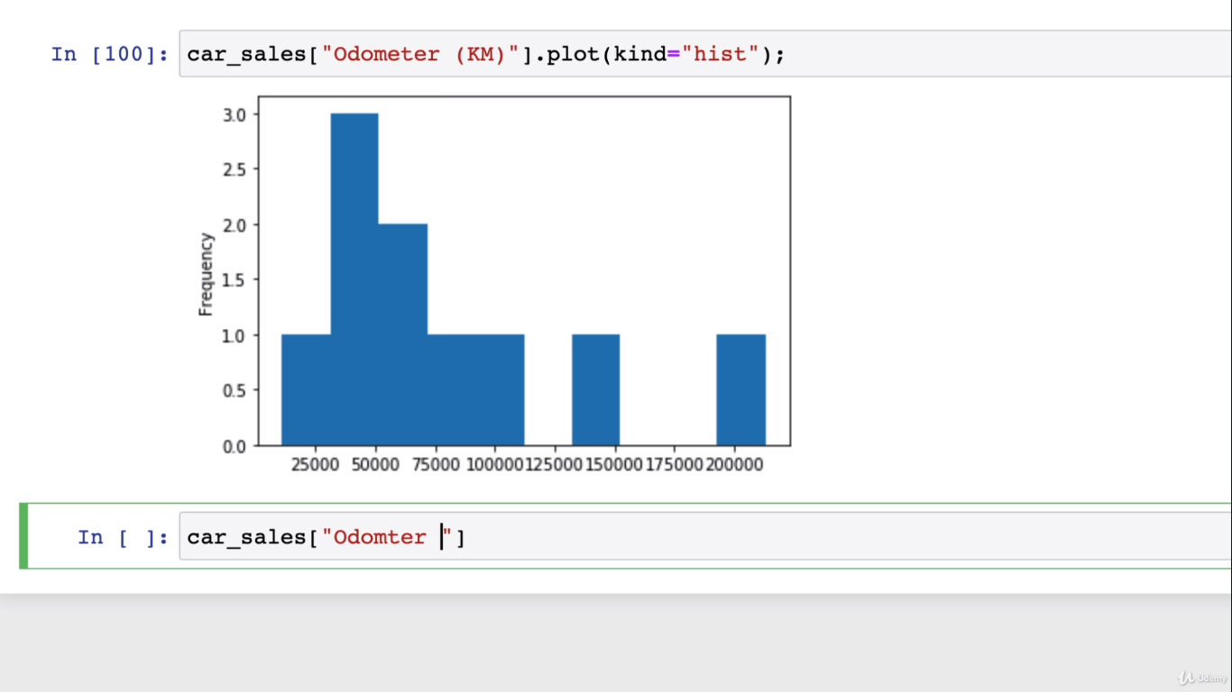

**Bins give group separation in visualization and choosing idealistic bins for our graph:**

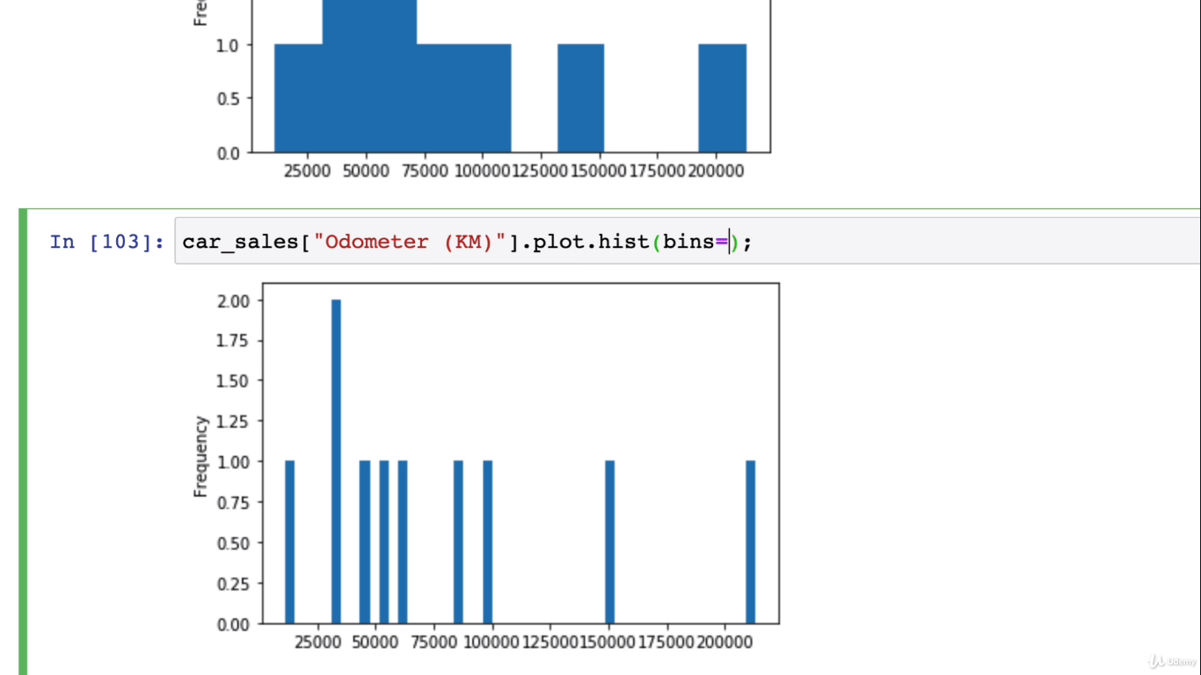

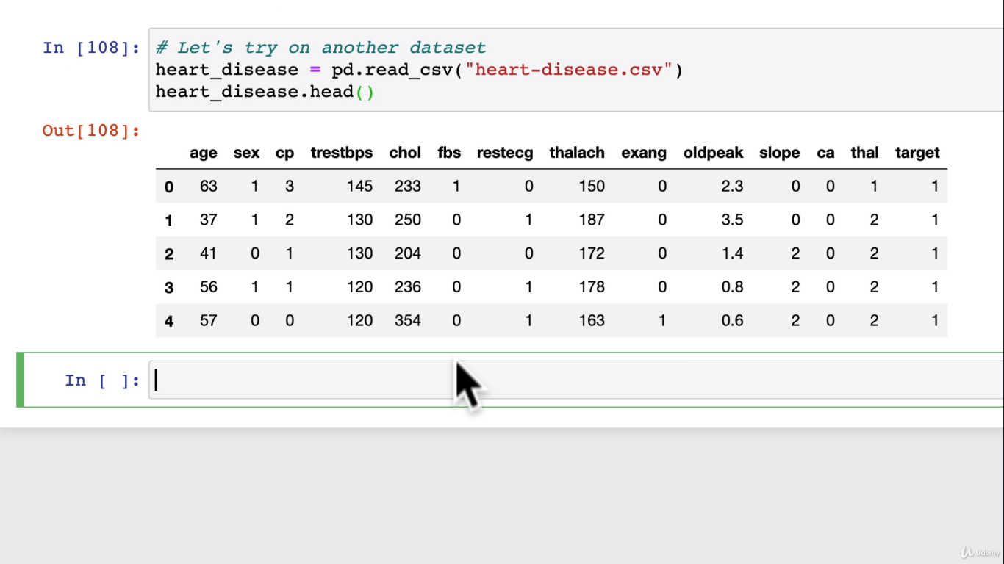

Lets do histogram on this based on distribution of age column:

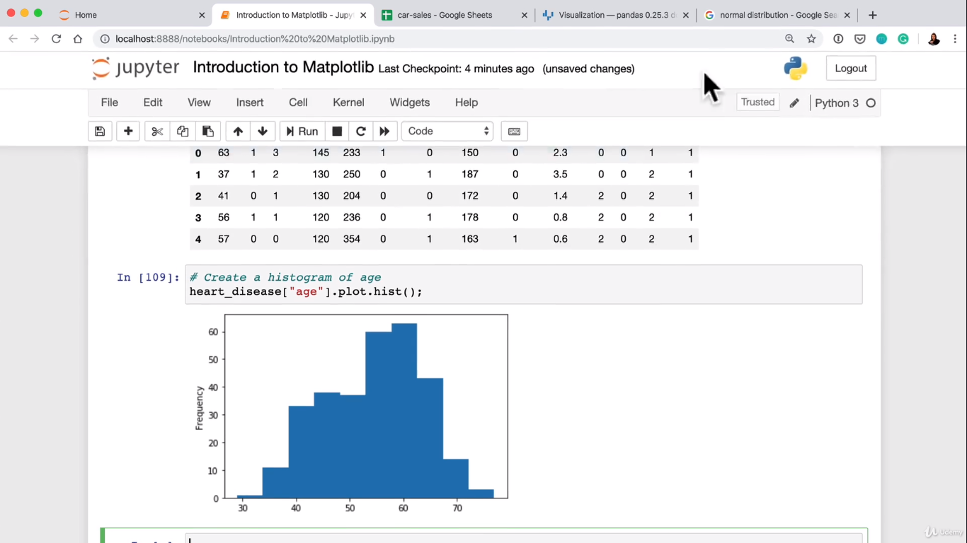

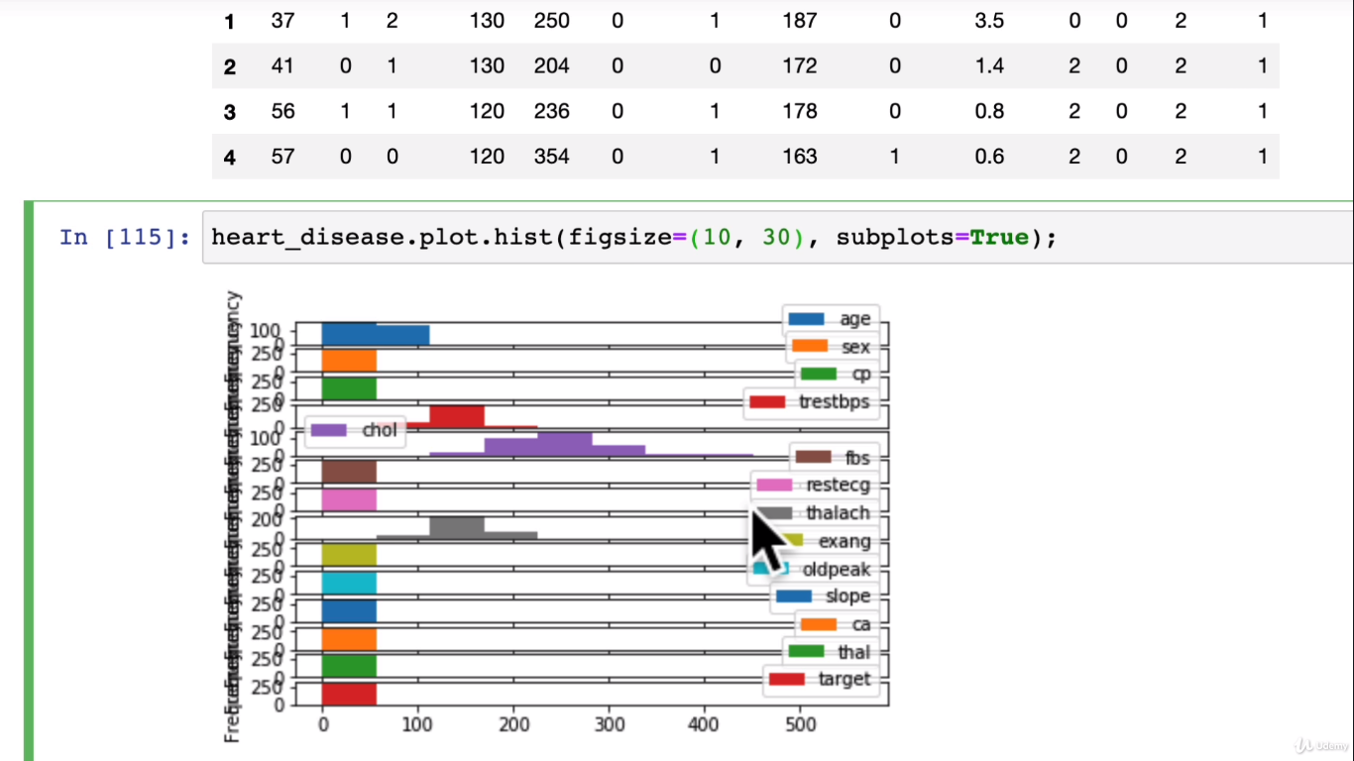

**Until now we were using direct numpy method of pyplot**

**Plotting using Object oriented API**

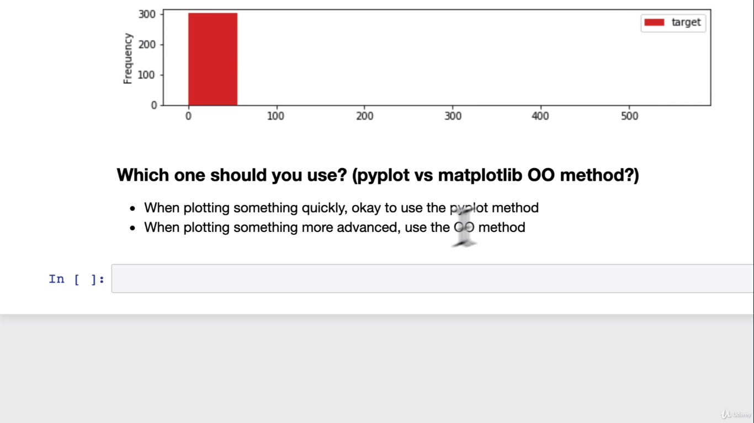

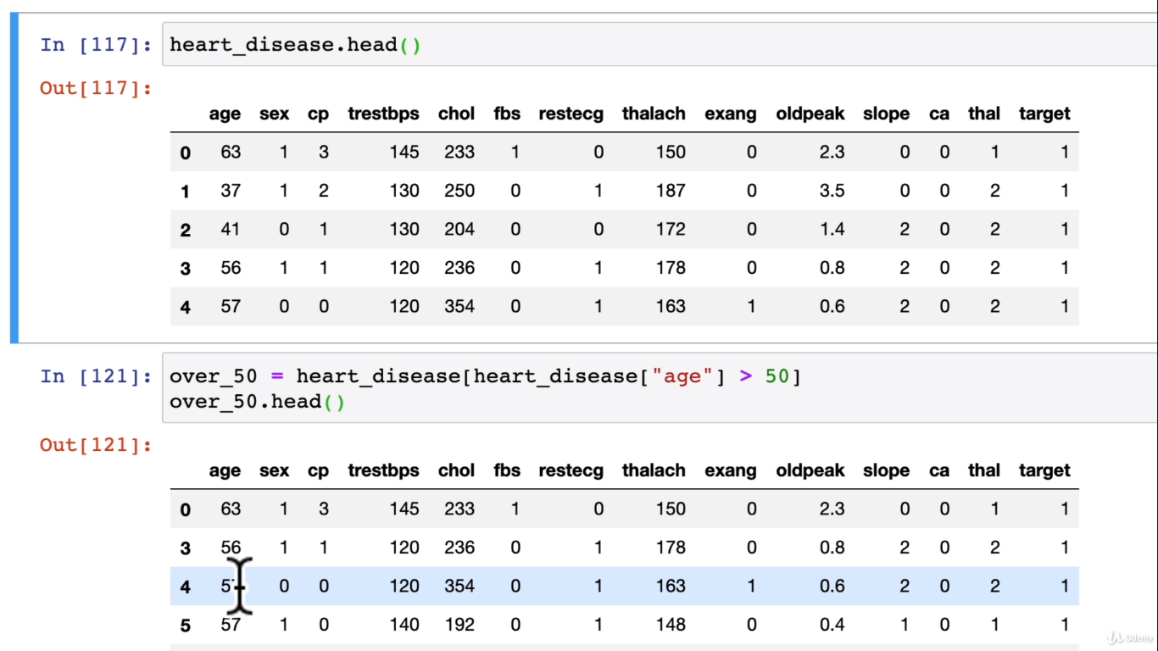

**Pyplot method:**

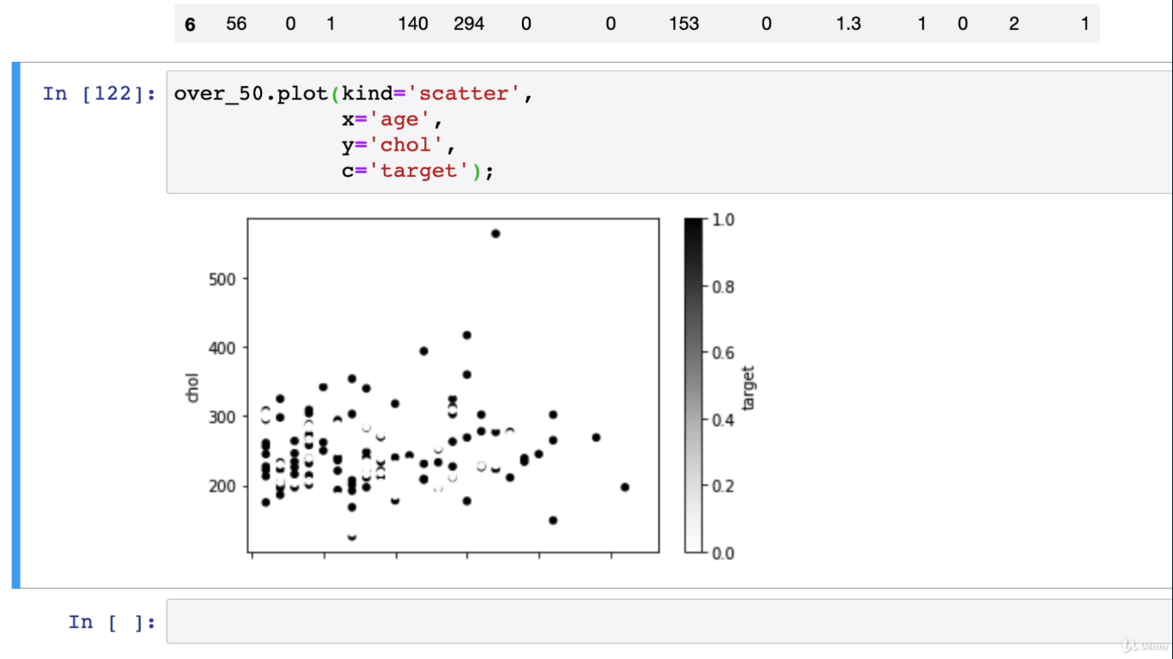

**# OO method:**

**Ax method:**

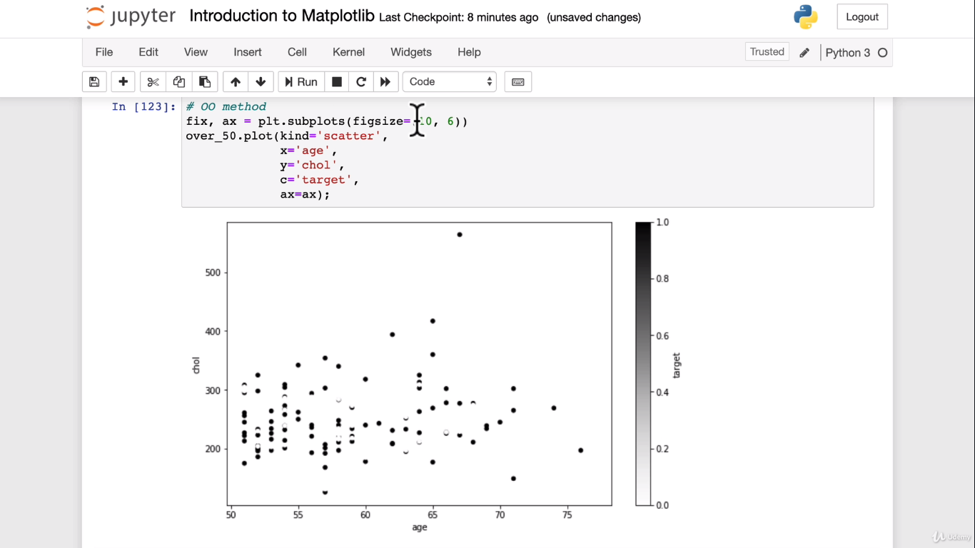

**We can set axis limits:**

**Ax.set_xlim([45,100]);**

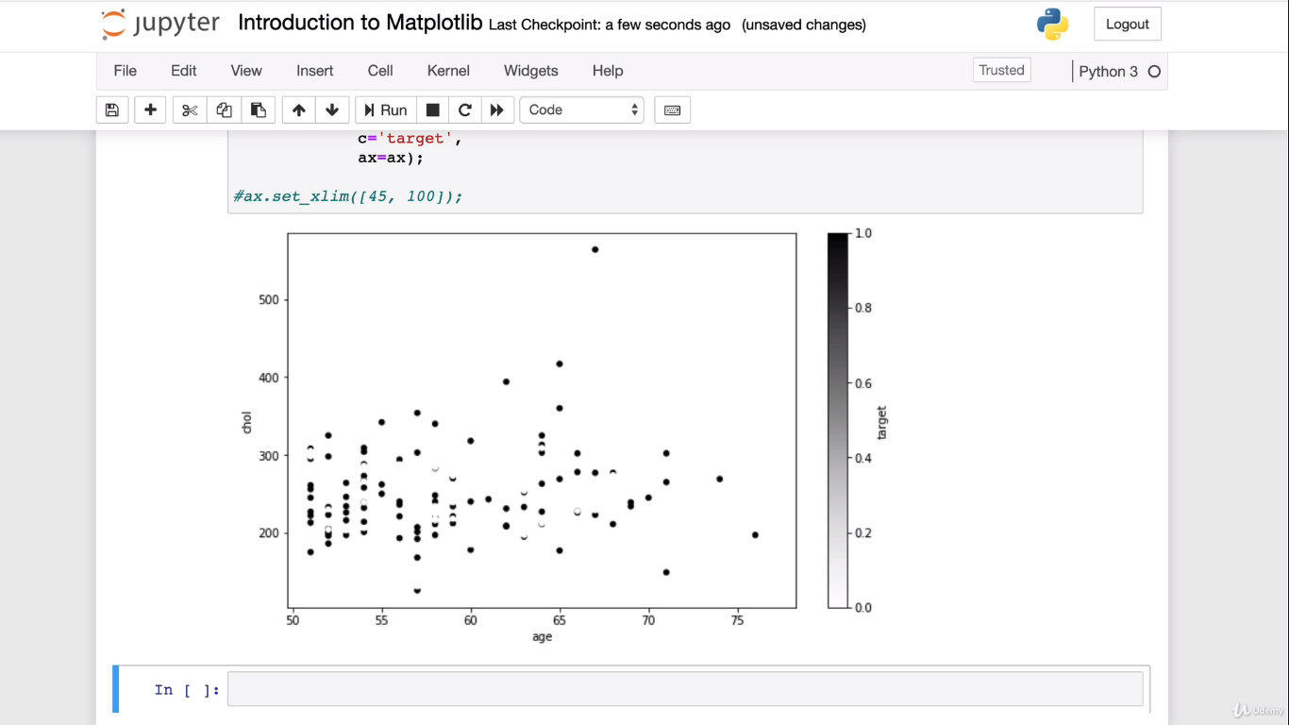

**Object Oriented method from scratch:**

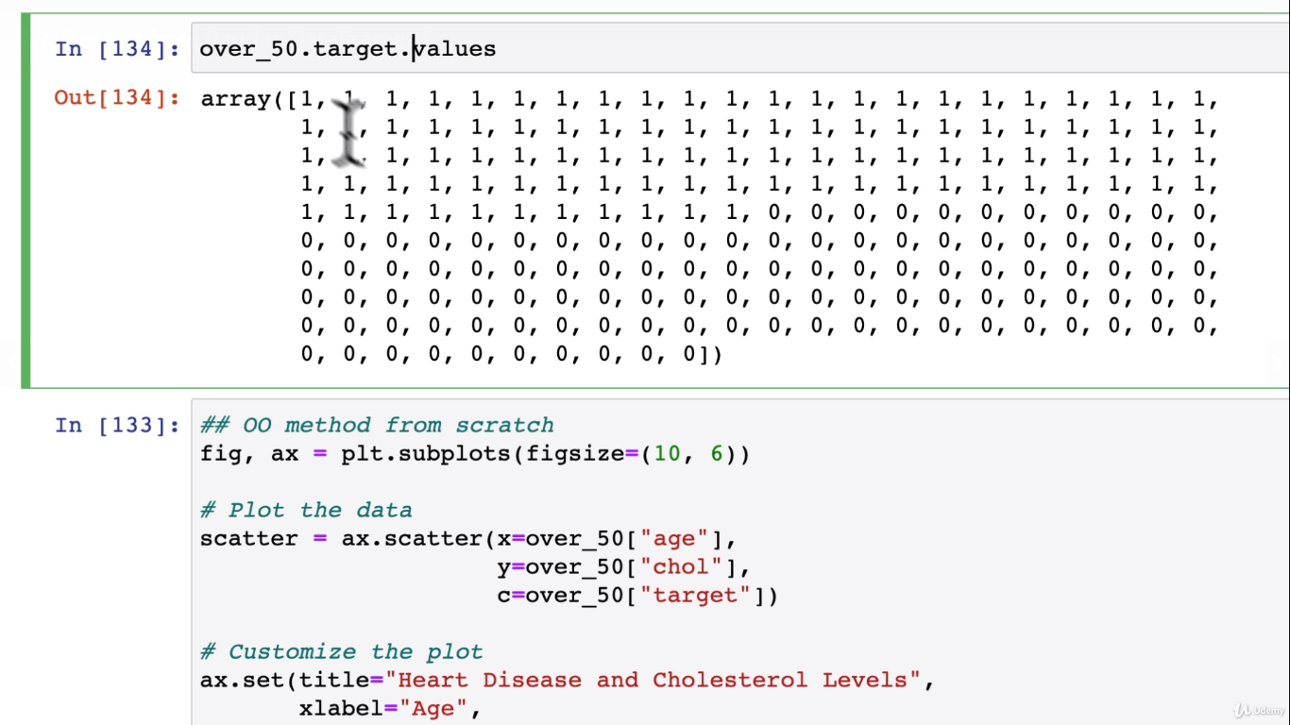

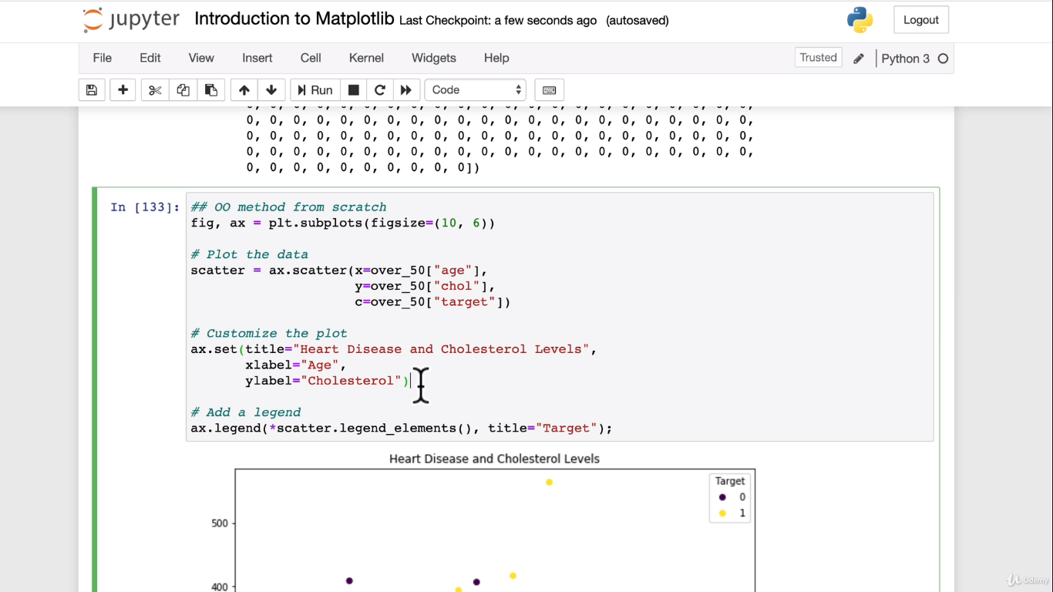

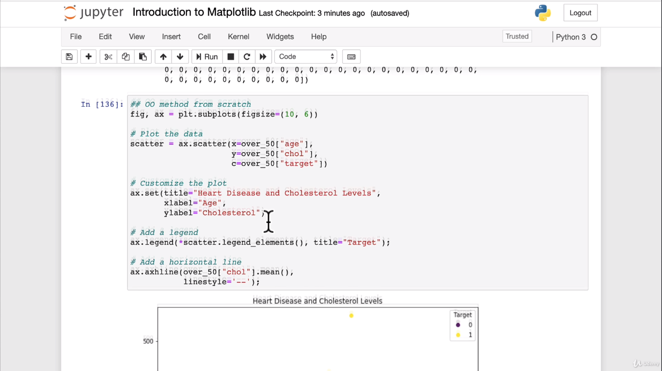

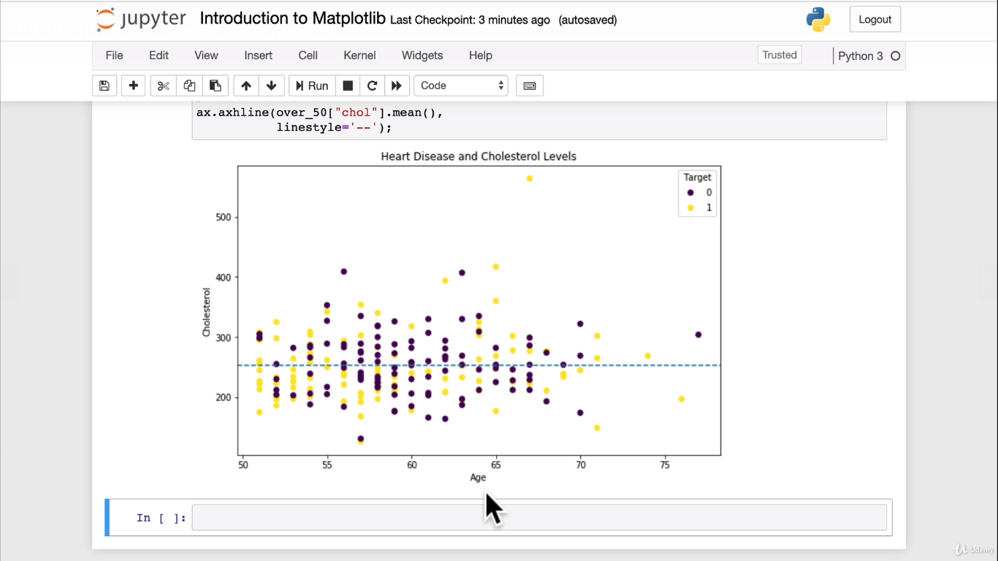

**Now let’s create a subplot:**

Below is the entore code to bring out the object oriented plot using common x axis and using mean value:

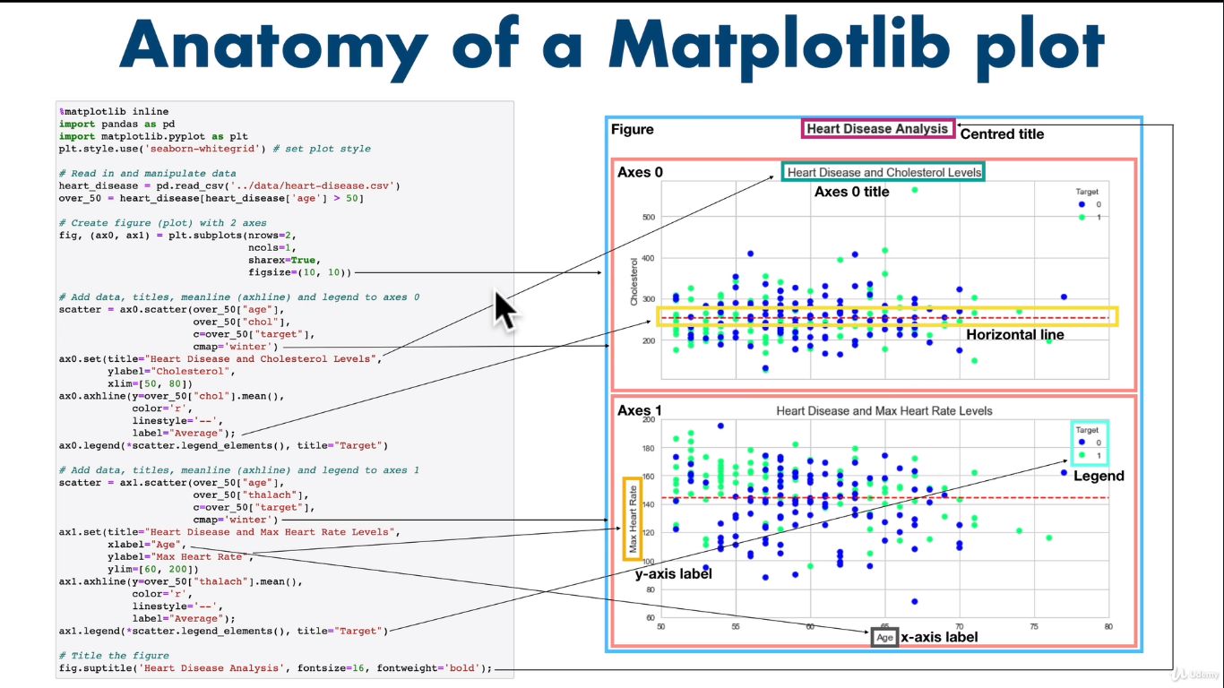

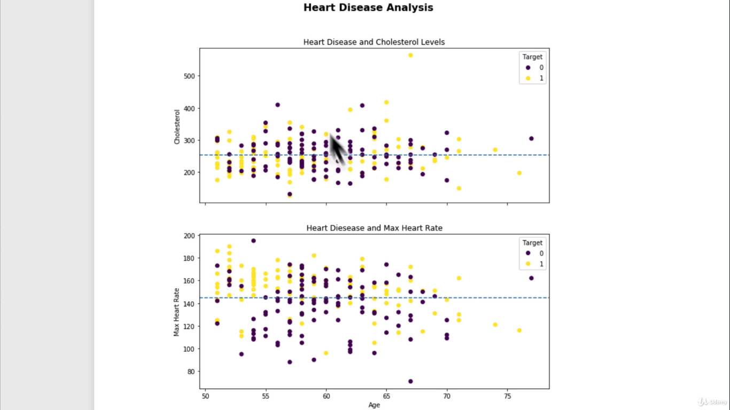

**Let’s customize the plots:**

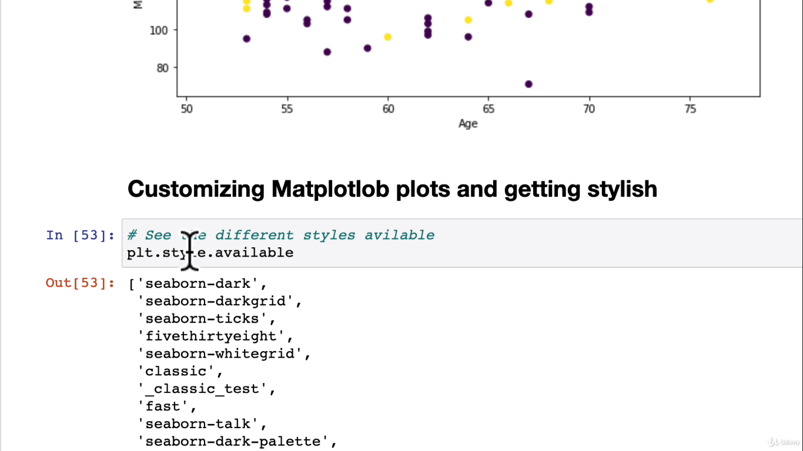

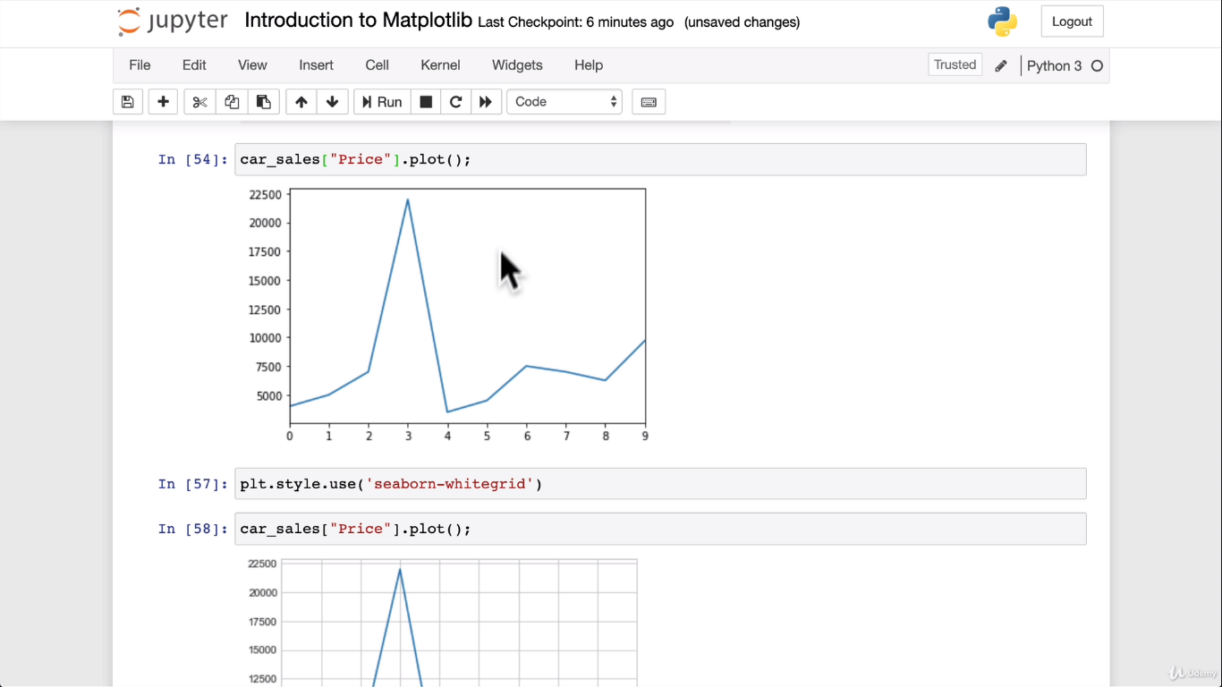

Another appearance style:

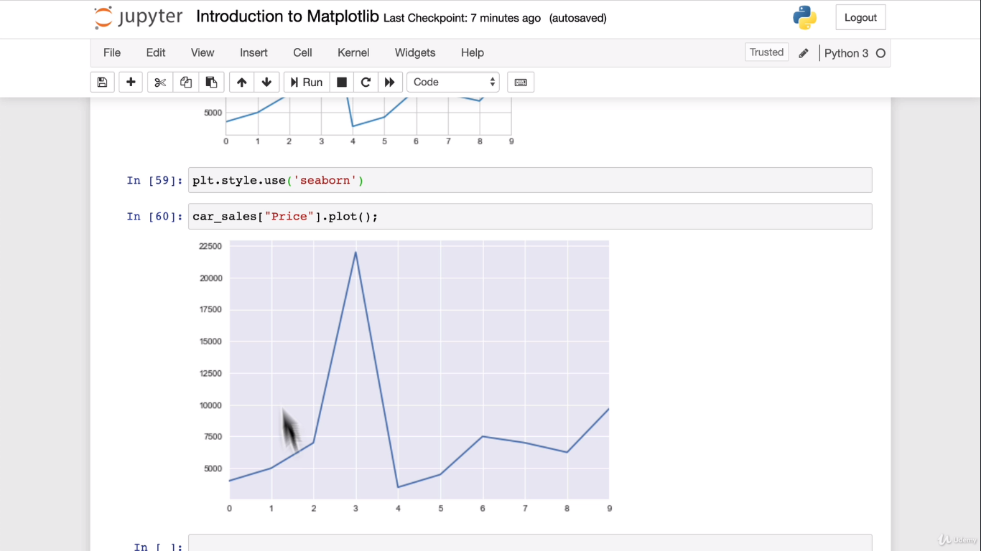

**Using plot like below:**

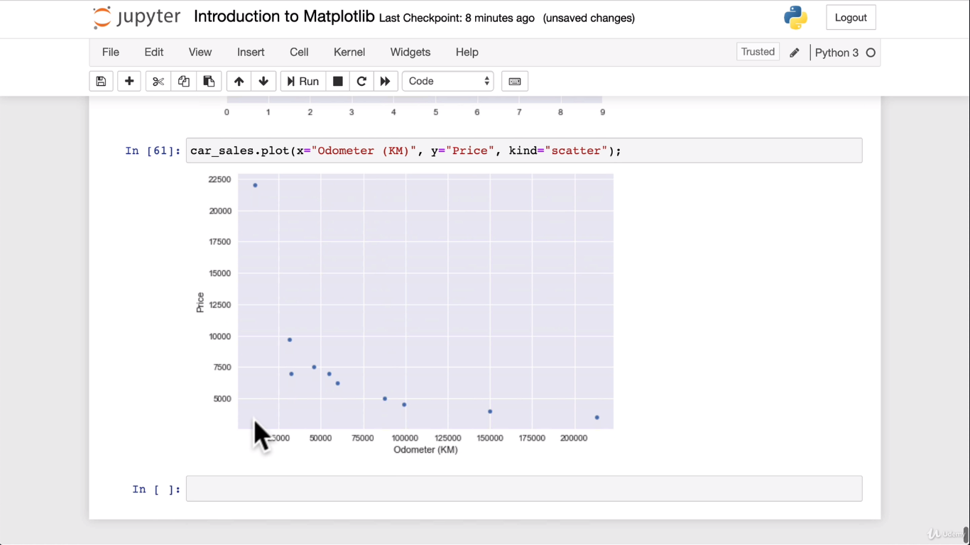

**Ggplot()**

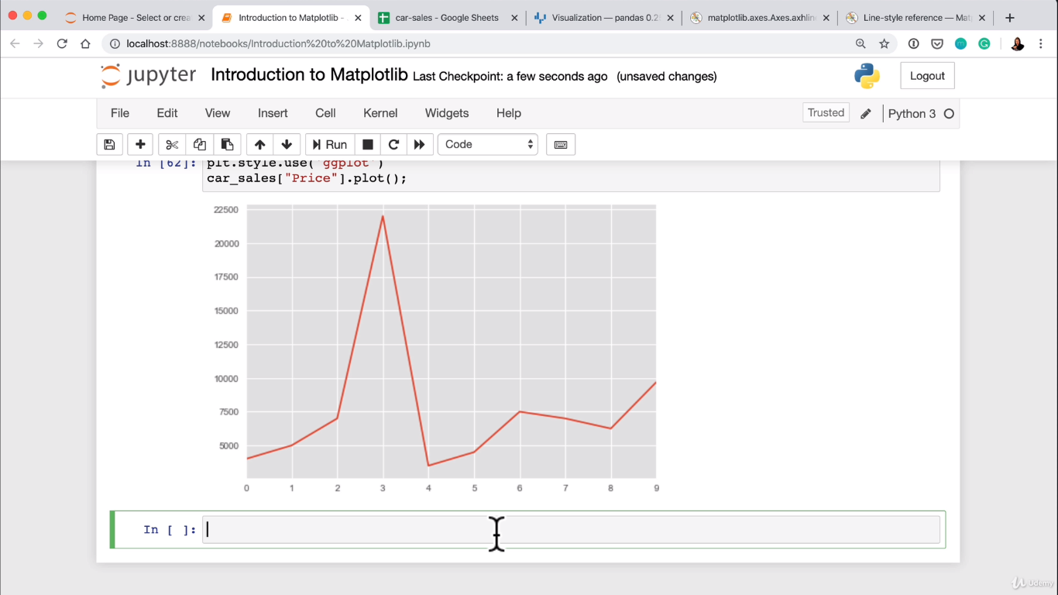

**Let’s create some data set:**

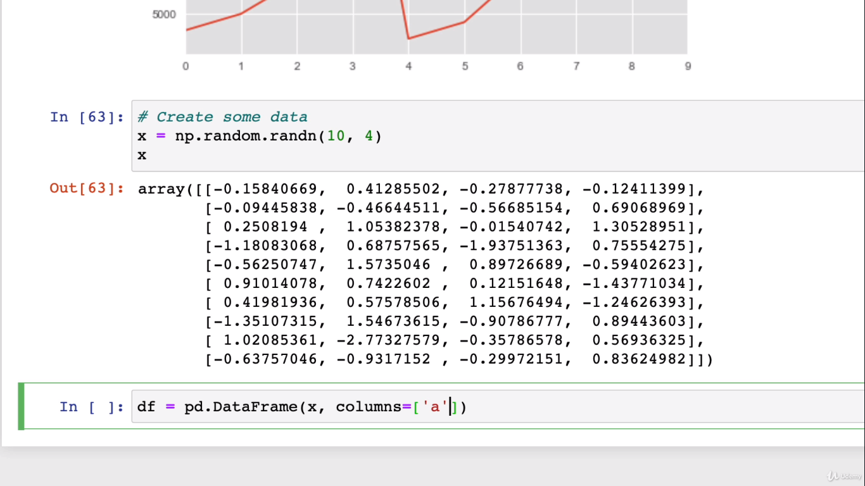

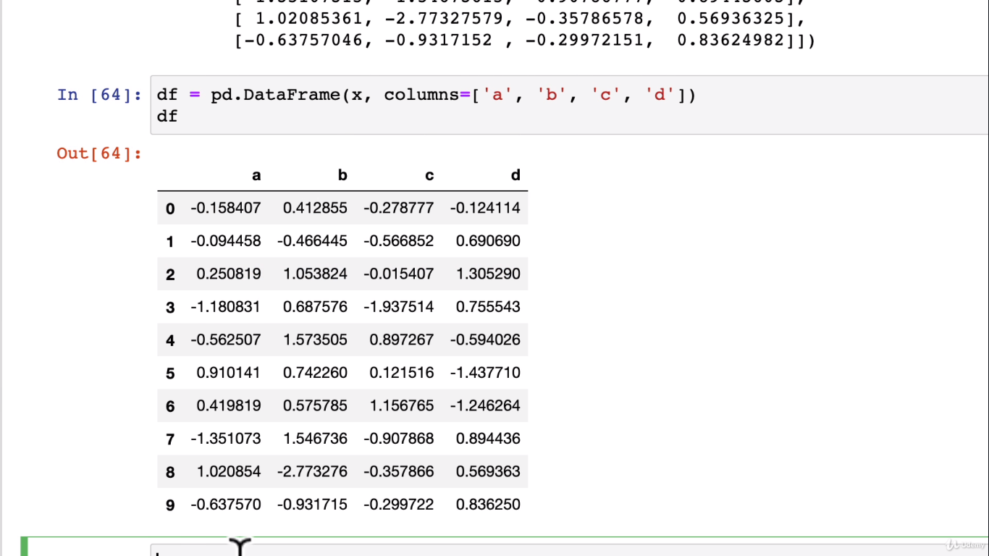

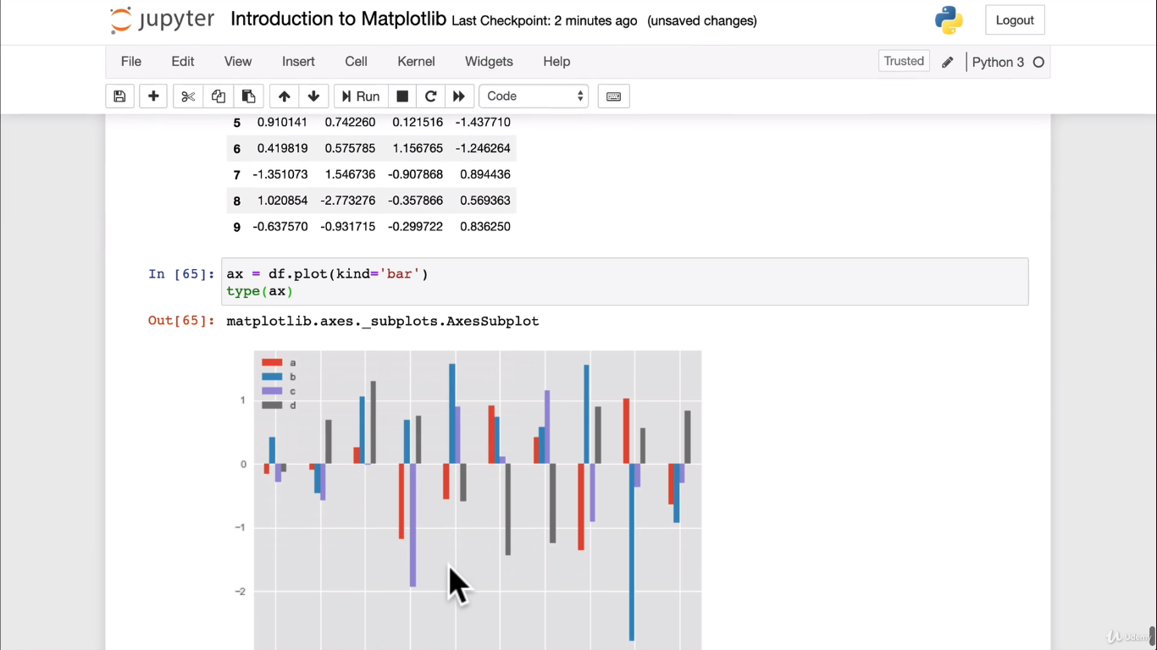

**Add legend,title etc:**

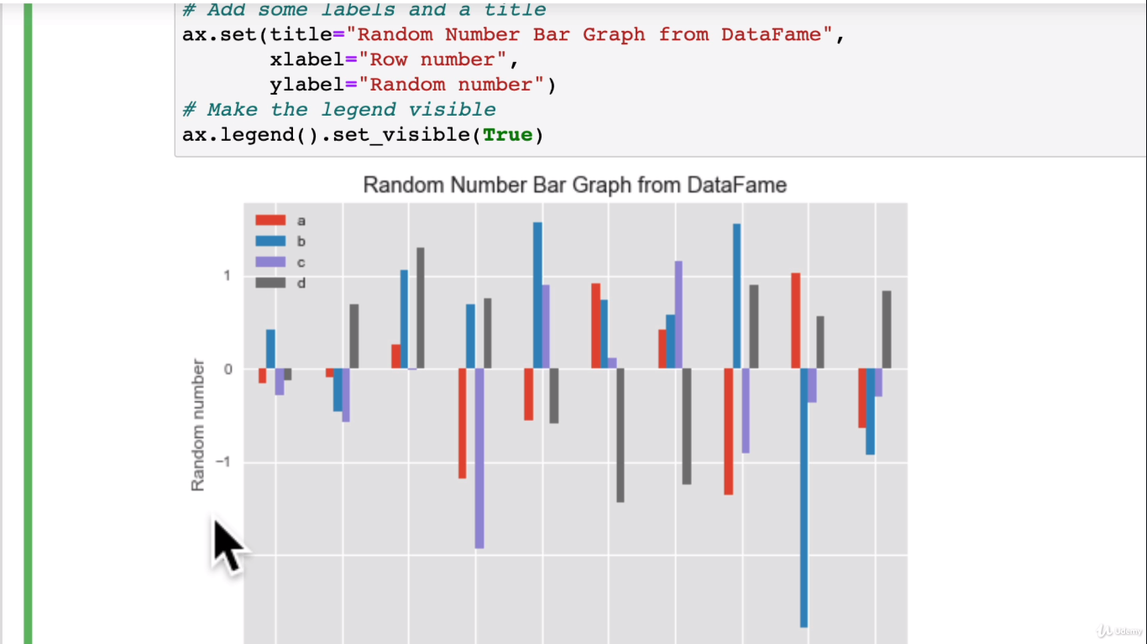

**Plotting subplot using OO method with different style:**

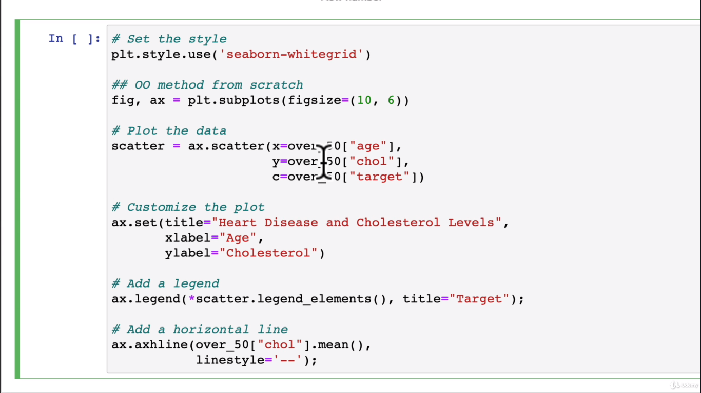

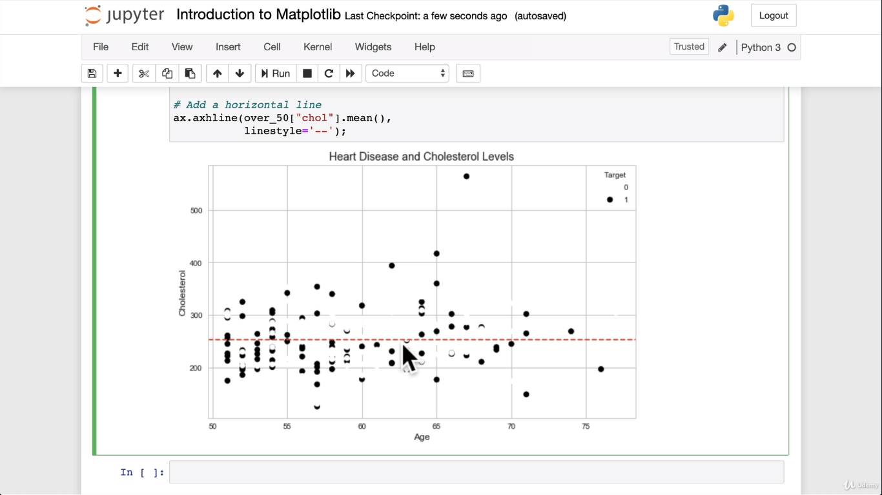

**Use of cmap:**

**Google Matplotlib colors tutorial:**

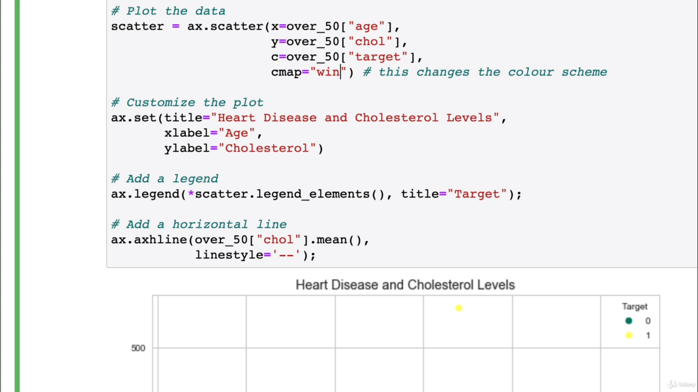

**Setting xlim and ylim and also cmap**

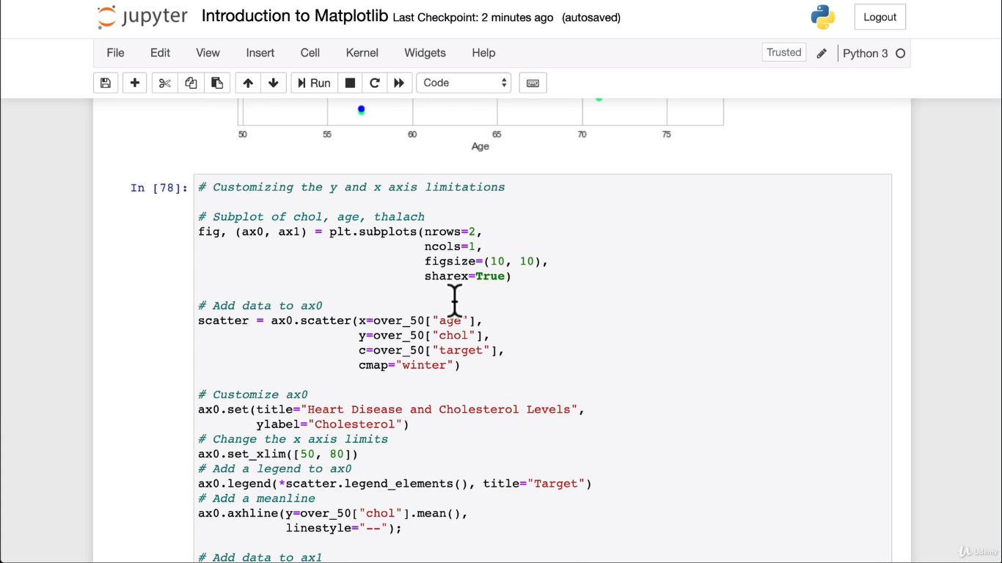

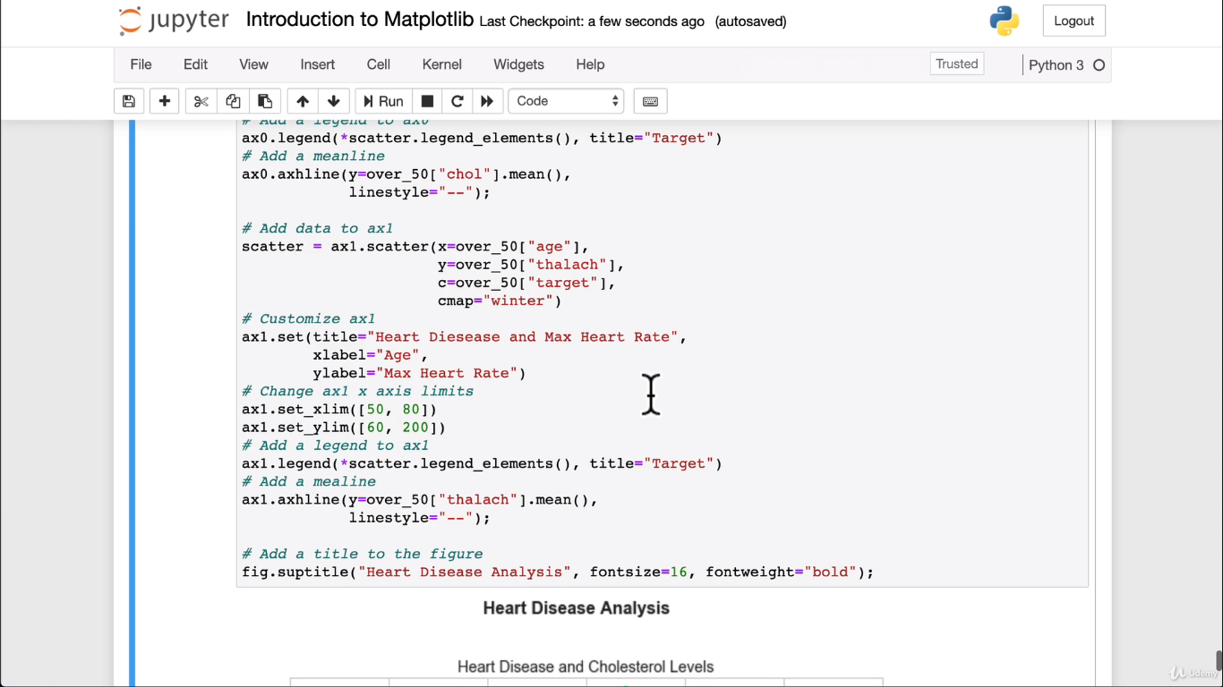

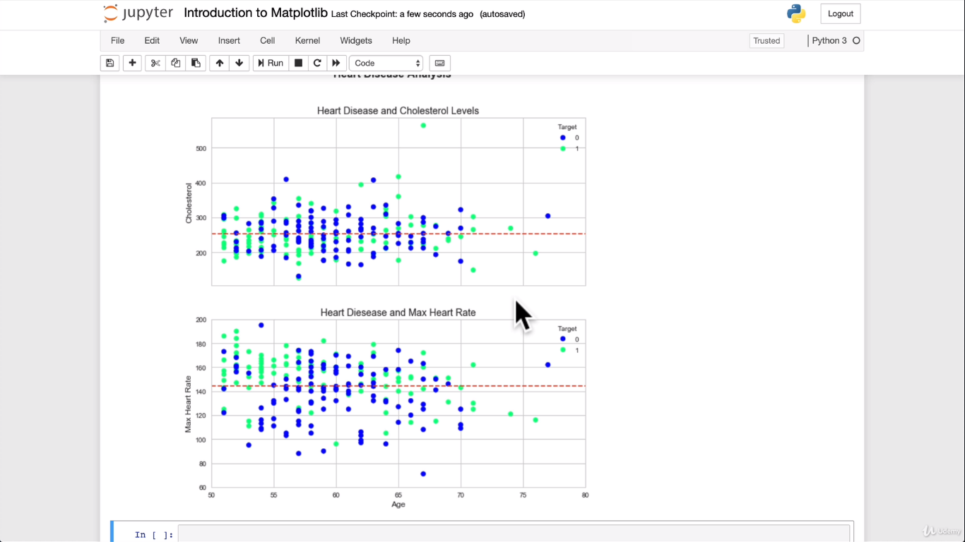

**Now saving the figure**

Fig.savefig(“heart-disease.png”)

**Scikit-Learn:**

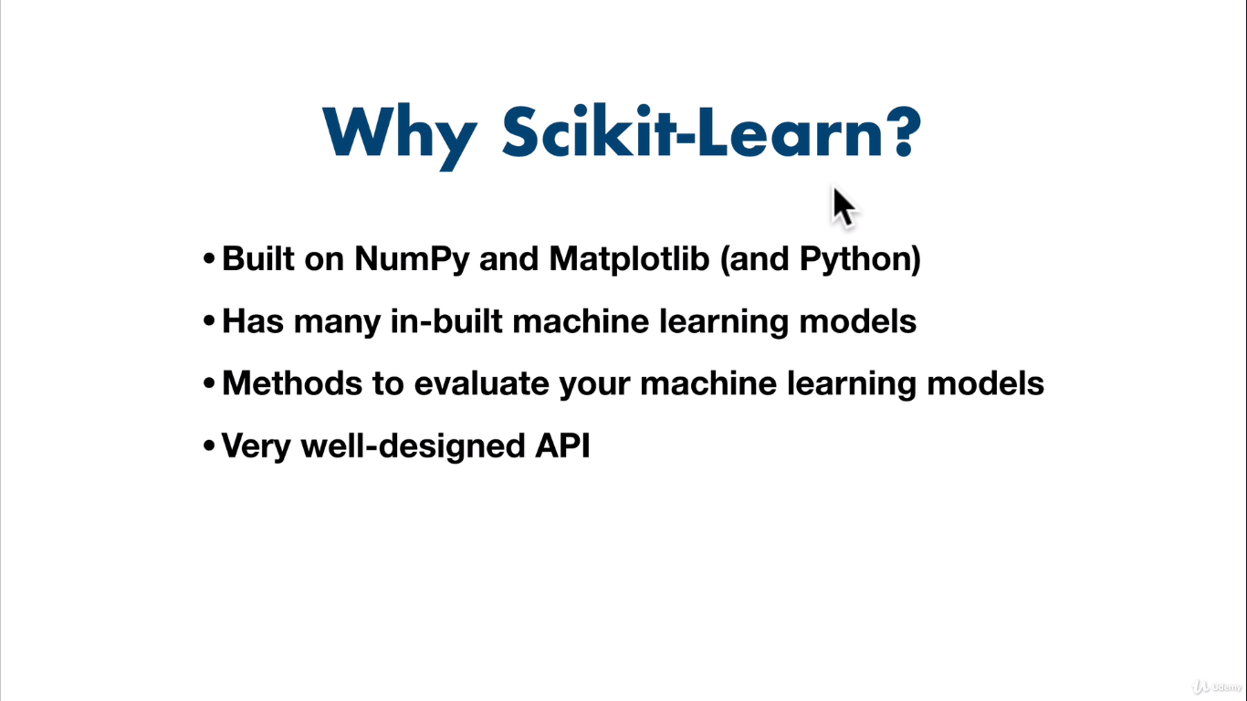

**Scikit_Learn workflow:**

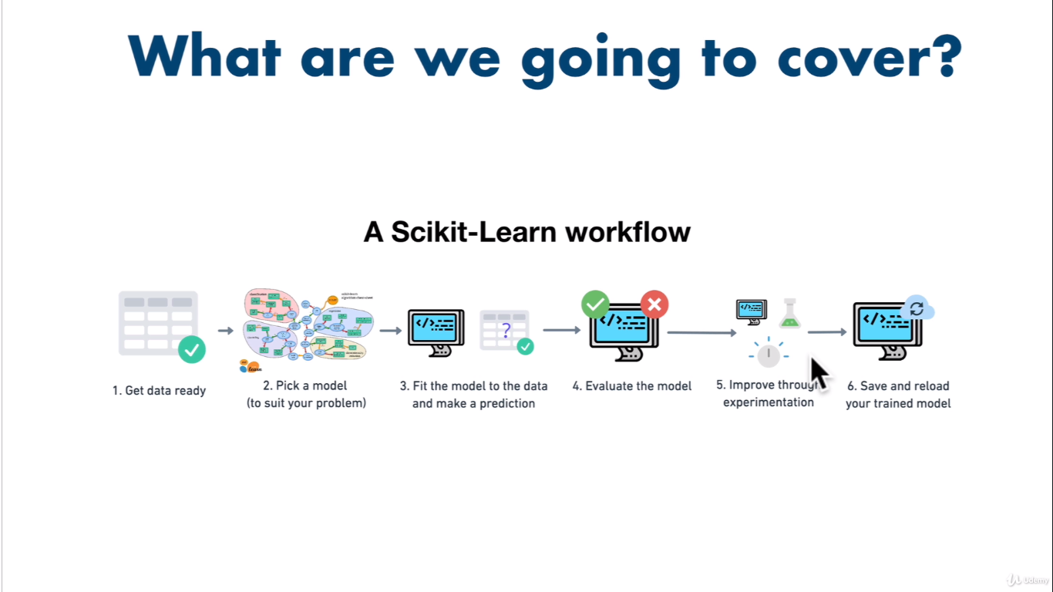

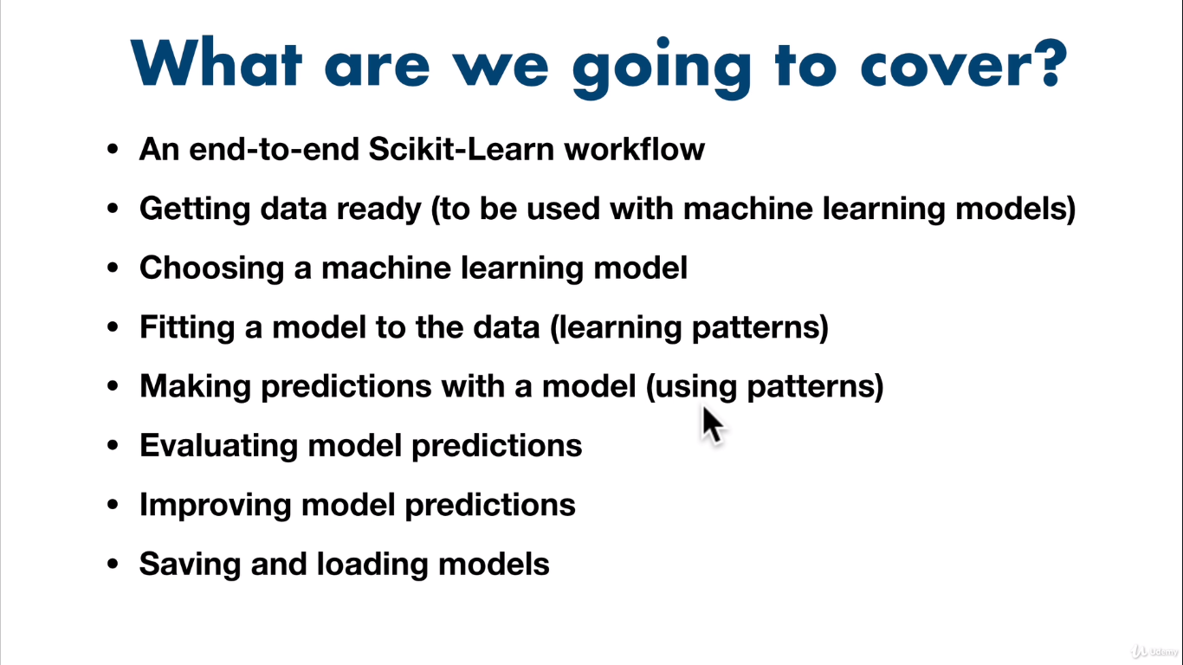

**Let’s do this through heart-disease project data:**

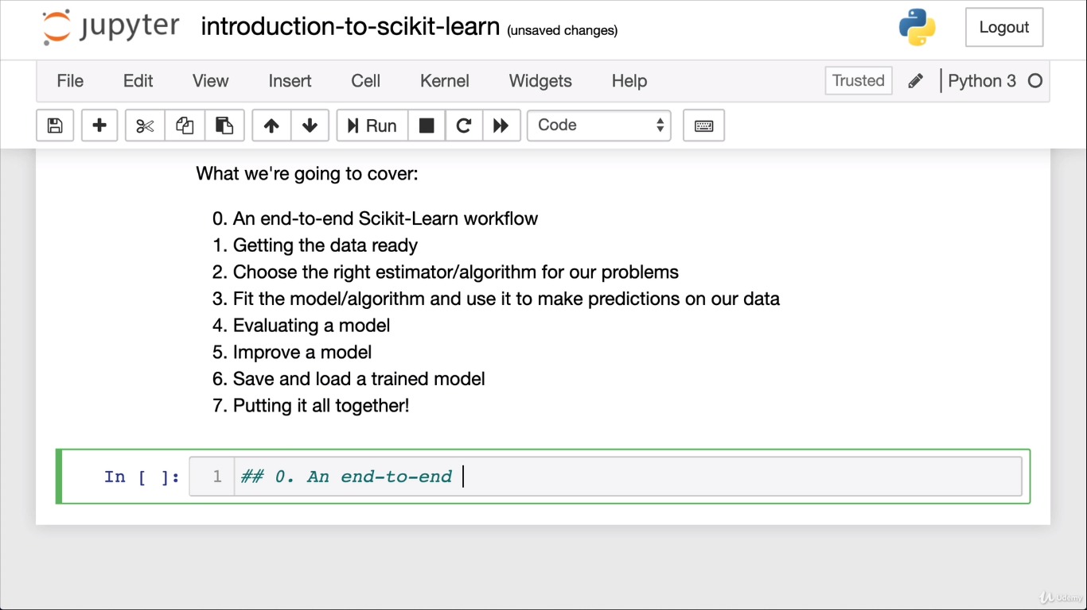

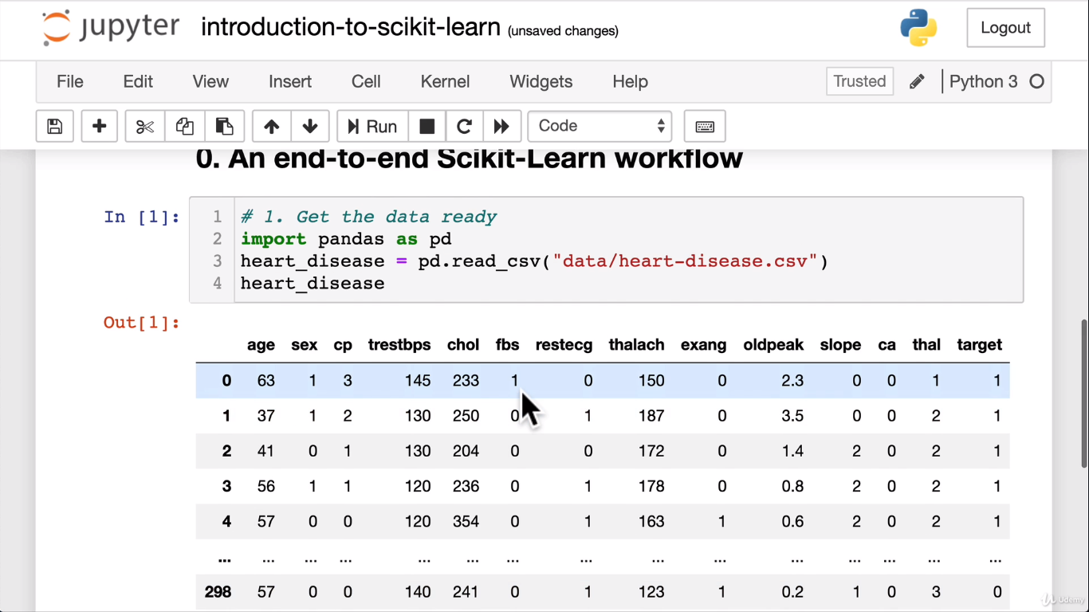

from sklearn.ensemble import RandomForestClassifier

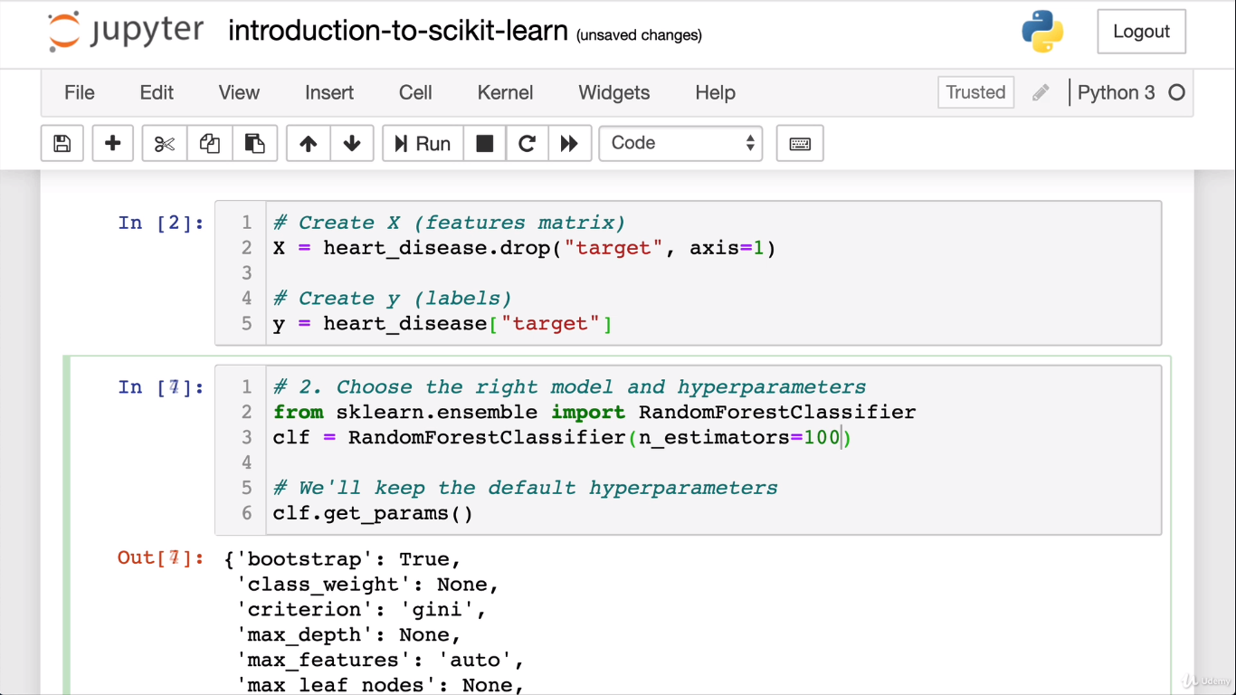

**Now split the data and make a prediction:**

**Now fit the data and make sure the shapes are equal.**

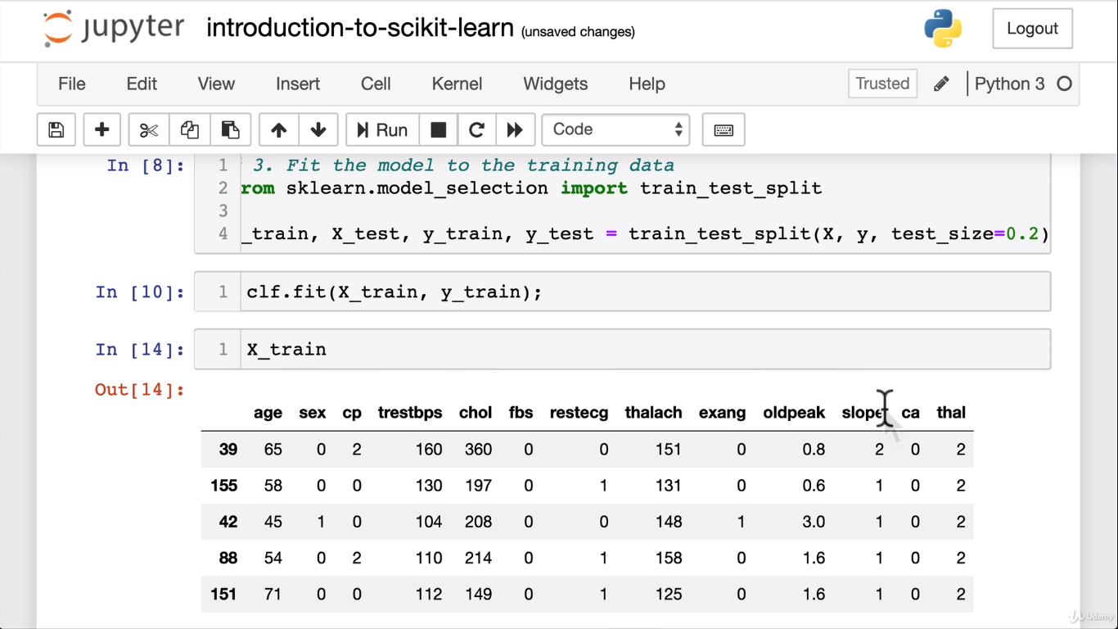

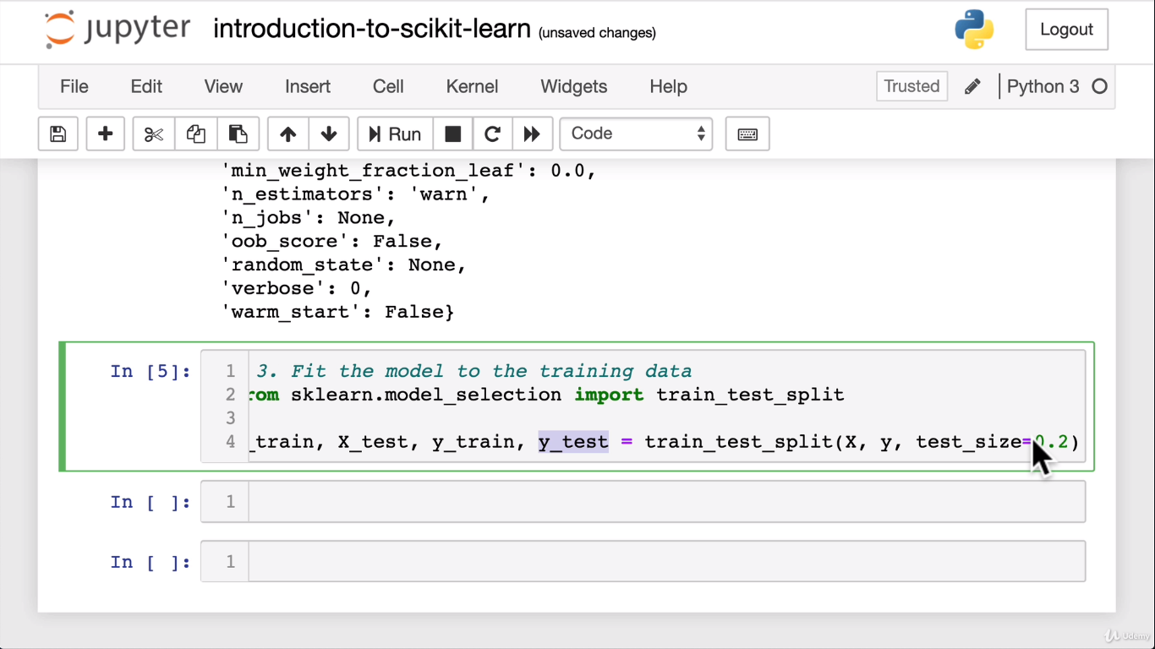

**Let’s predict the model**

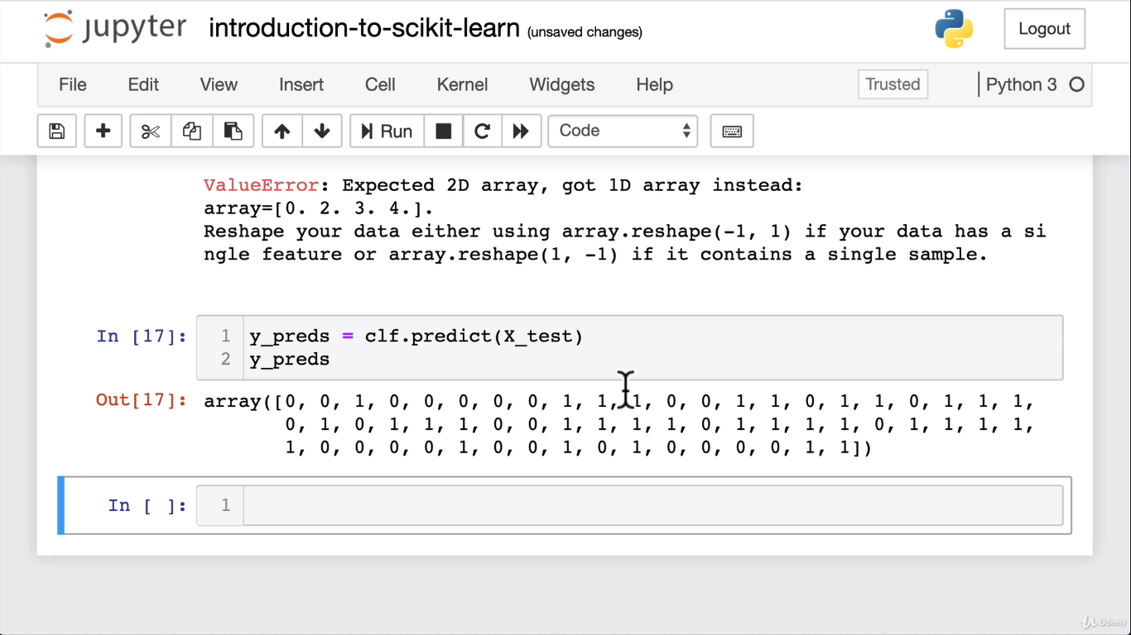

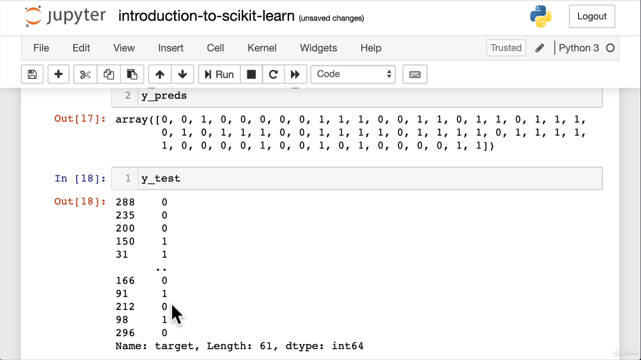

**Now see the percentage of the training model:**

**1 means 100%**

**.75 means 75% accuracy.**

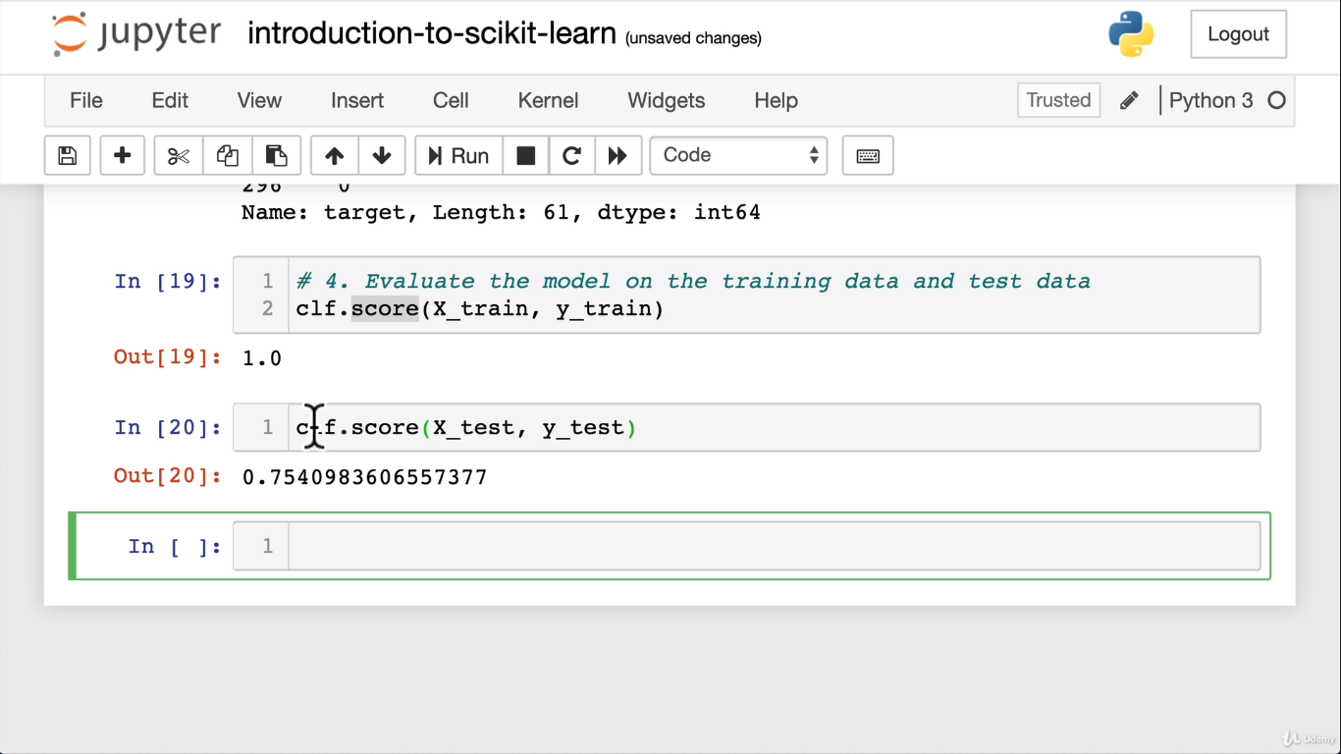

**Let’s import more matrix:**

from sklearn.metrics import classification_report,confusion_matrix,accuracy_score

print(classification_report(y_test,y_preds))

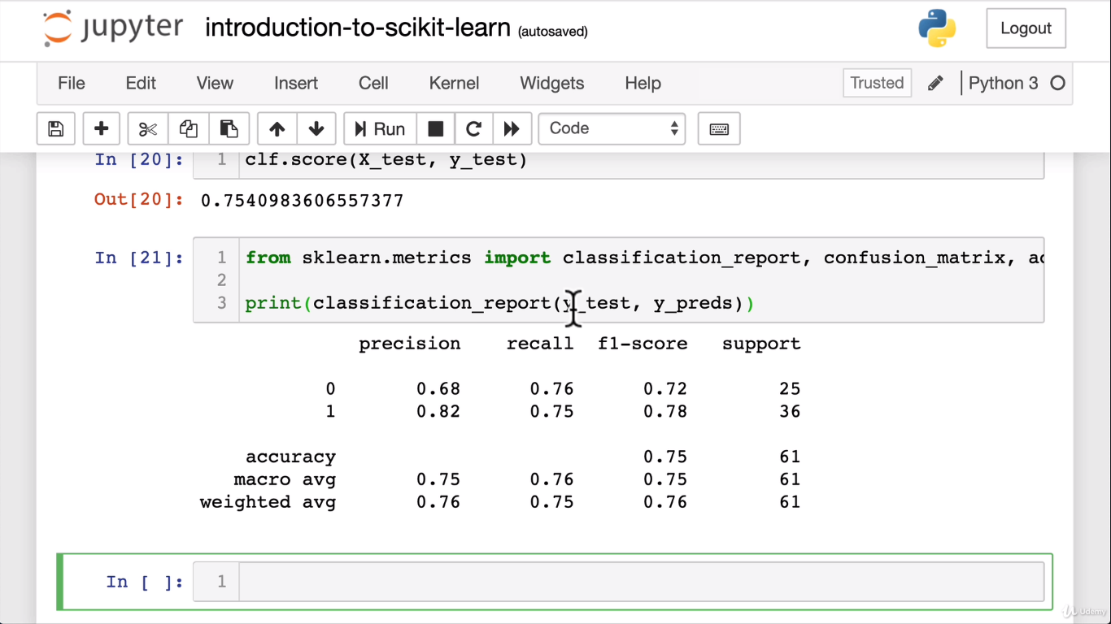

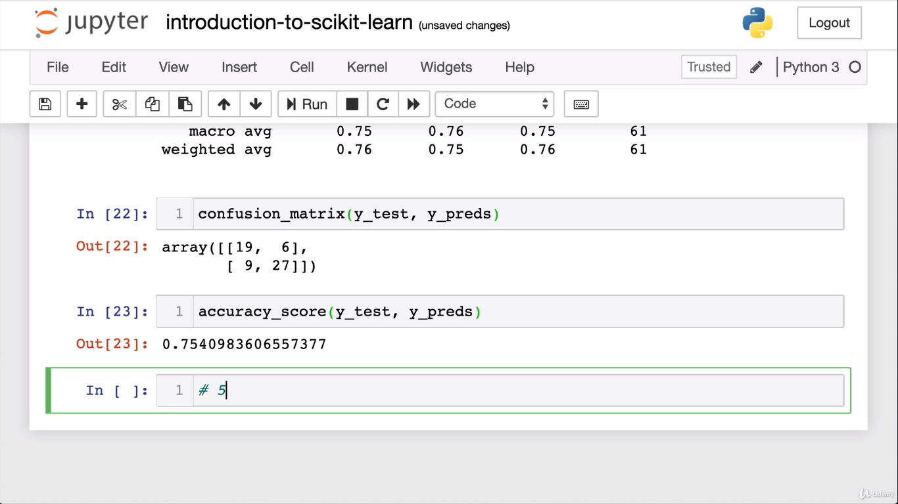

**Now let’s improve the model:**

We are not happy with the accuracy score so let’s improve the model by trying different value for nestimators which is one of the hyper parameter dials on machine learning to improve it.

Now let’s try different nestimators with different values in a for loop

Limit it to 2 decimal spaces like below for test data

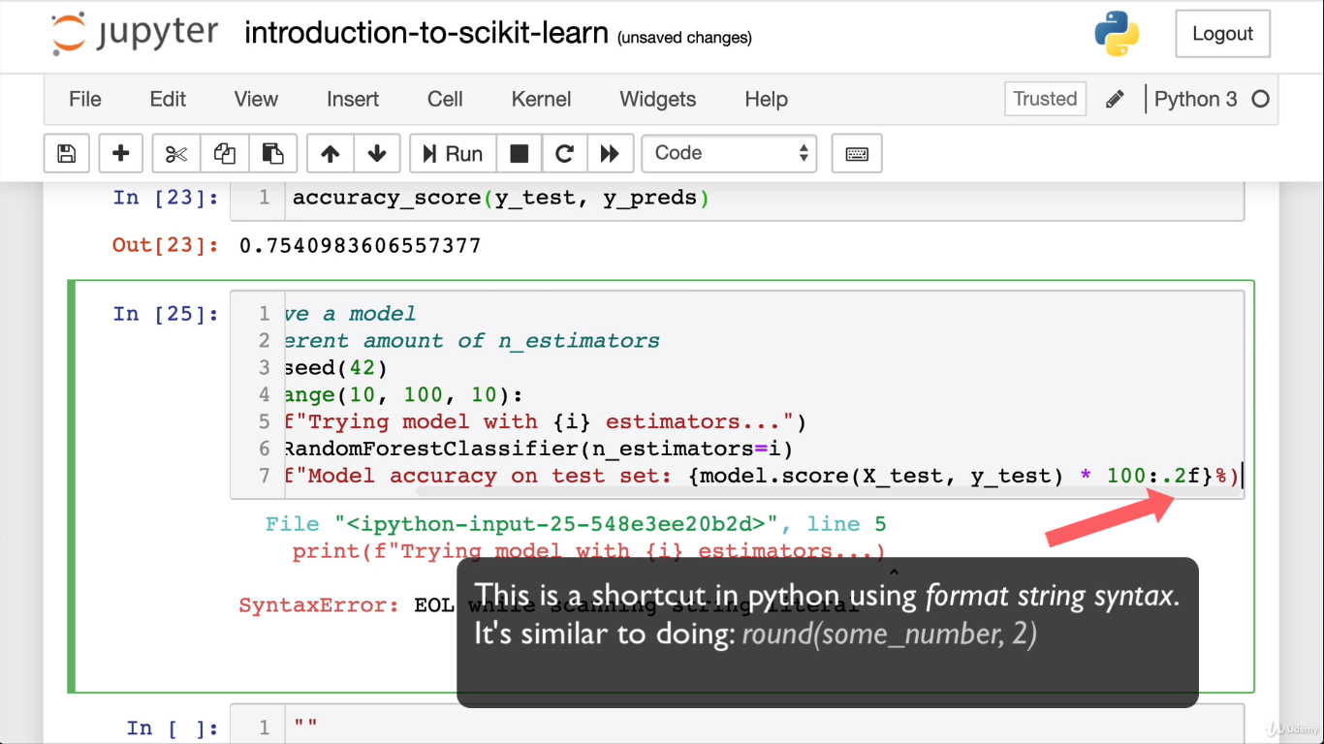

Now the best model has come out when we adjust it to 20 estimators to get 83.61% accuracy

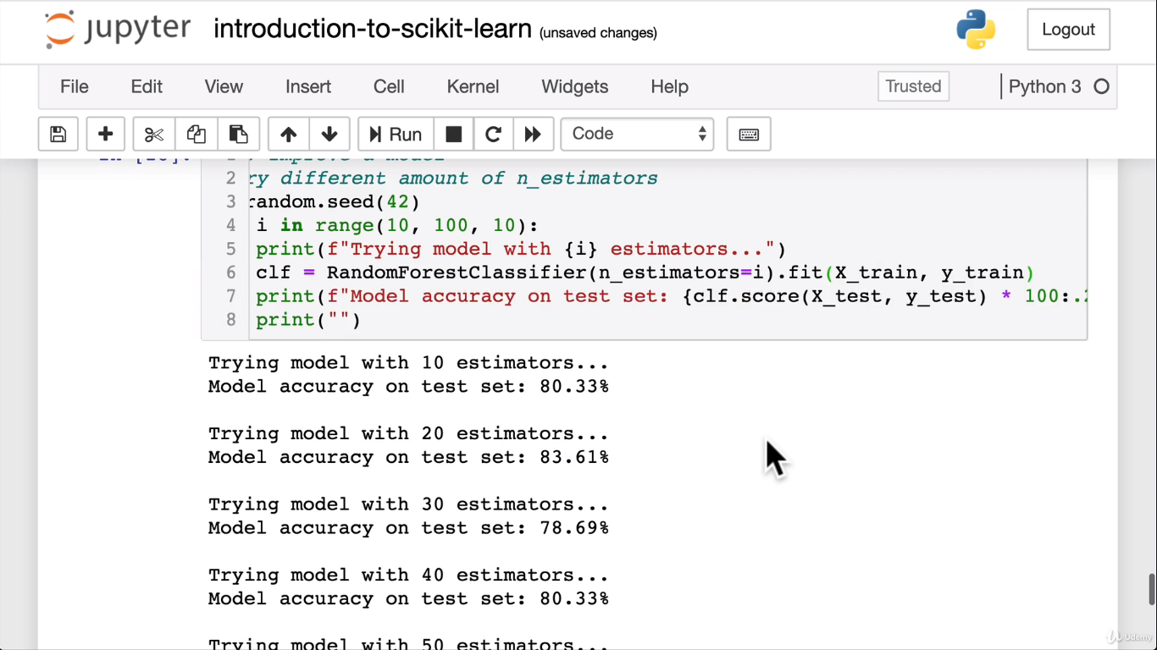

Now save the model using **python pickle** package:

Import pickle package

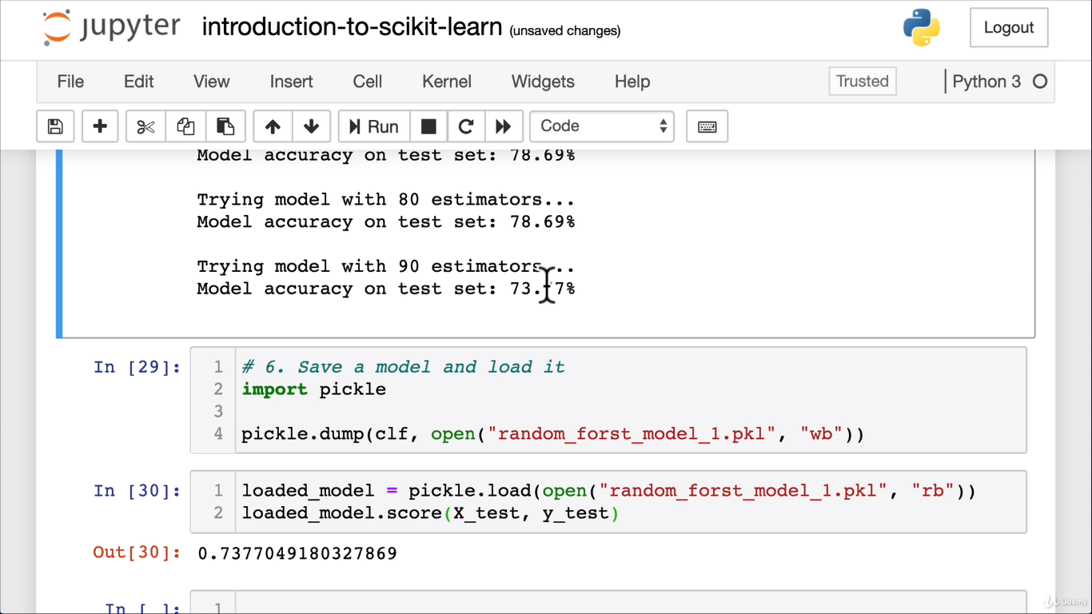

You can ignore warnings by importing warnings package:



To see scikit-learn version, please use below:



**To upgrade a package:**

Example:

Conda update scikit-learn 🡪 command to upgrade the package

List packages:

Conda list scikit-learn

If it doesn’t upgrade then see for the dependencies:

Conda search scikit-learn –info

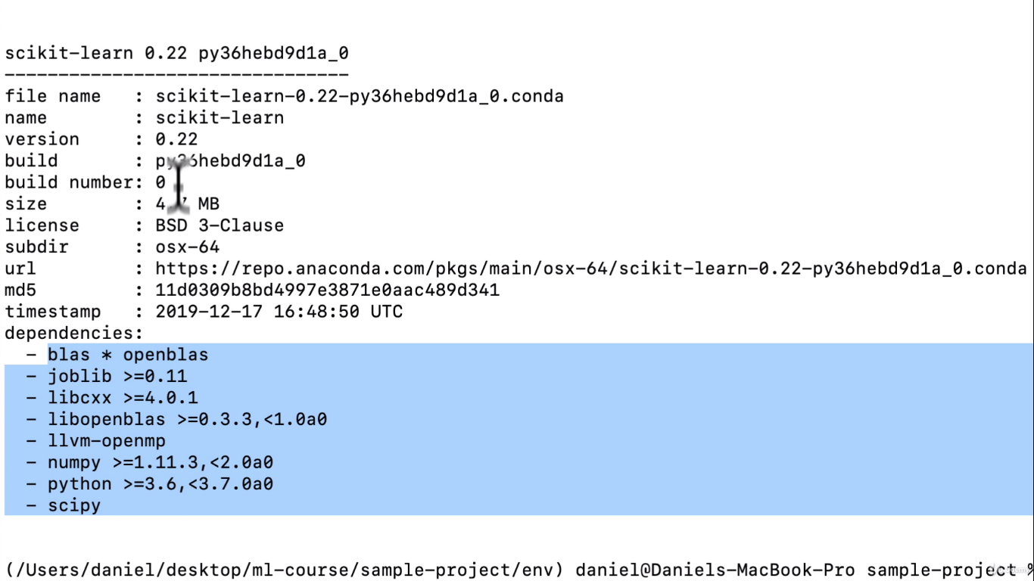

We need to have above dependencies:

So in order to uninstall and install the packages , please use below:

Conda uninstall scikit-learn python

After unsiatlling, pelase install with correct version

Conda install scikit-learn=0.22 python=3.6.9 matplotlib pandas numpy jupyter

**Getting our data ready:**

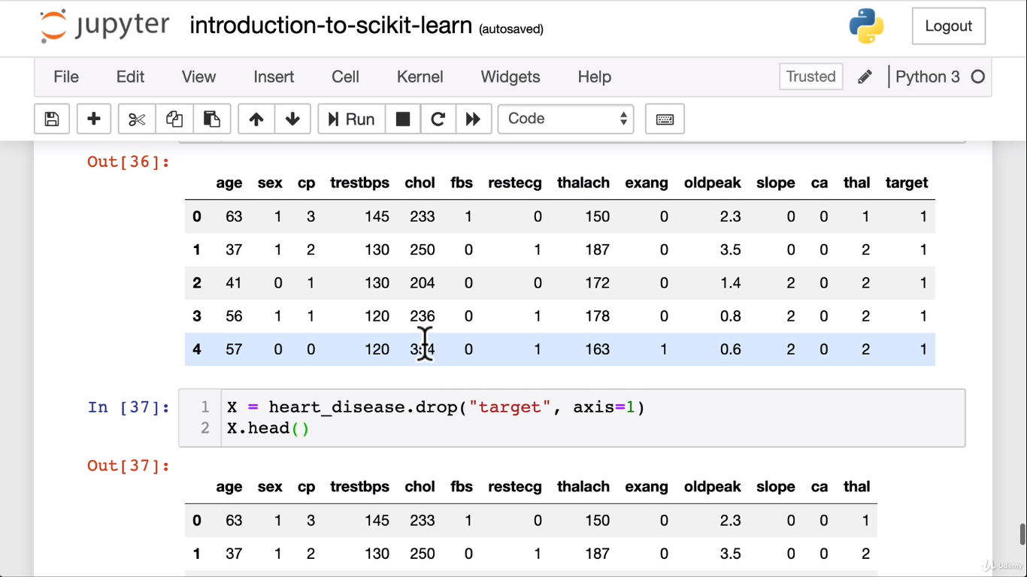

Now split the data into training and test sets:

from sklearn.model_selection import train_test_split

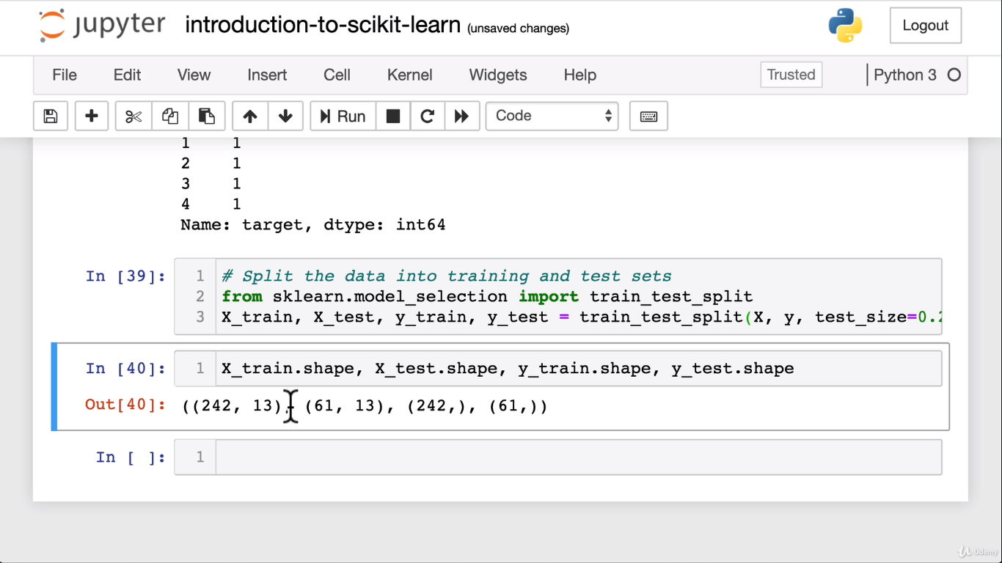

We have split our data as training = 80% and test = 20%

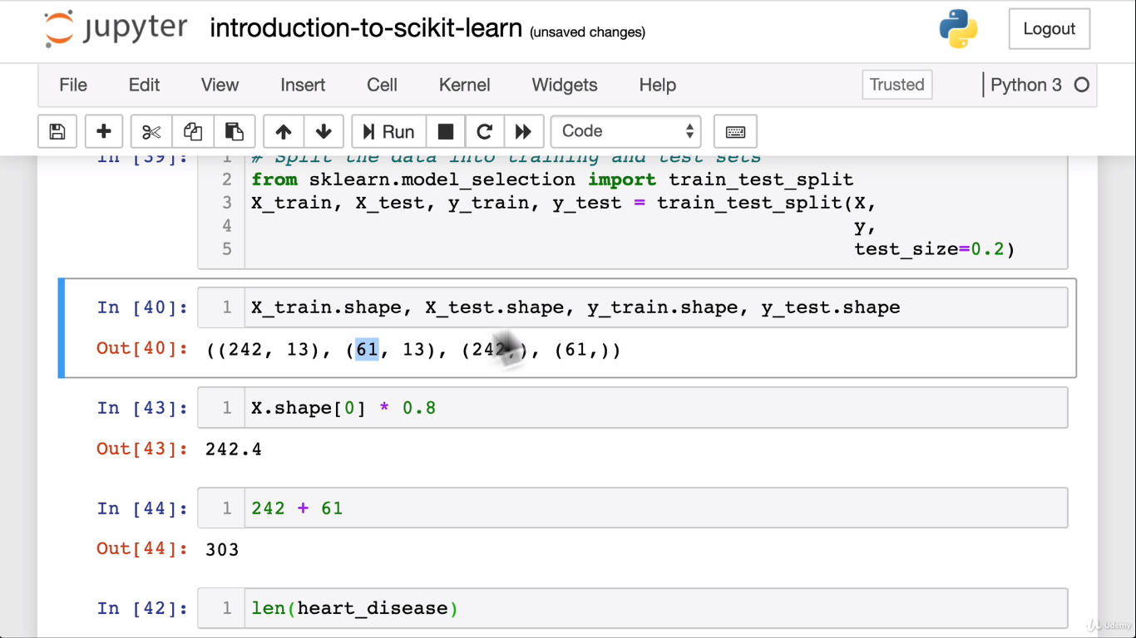

**Cleaning up data or Data cleansing:**

